VIETNAM NATIONAL UNIVERSITY OF HOCHIMINH CITY

THE INTERNATIONAL UNIVERSITY

SCHOOL OF COMPUTER SCIENCE AND ENGINEERING



**PROJECT REPORT**

**WEB APP FOR SUPPORTING INTERNSHIPS AT AN**

**INTERNATIONAL UNIVERSITY**

By

Tran Hai Nam

Advisor:

Dr. Huynh Kha Tu

A thesis submitted to the School of Computer Science and Engineering

in partial fulfillment of the requirements for the degree of   
Bachelor of Information Technology/Computer Science/Computer Engineering

Ho Chi Minh City, Vietnam  
Year 2023

APPROVED BY: ________________________________ ,   
Tran Hai Nam – ITITIU19161

________________________________

THESIS COMMITTEE   
(Whichever applies)

# ACKNOWLEDGMENTS

To complete the thesis, I have a lot of help and support from many organizations, agencies, and people to finish my thesis. Permit me to extend my most sincere appreciation to all organizations and individuals who have rendered themselves indispensable to me during the course of my studies and research on this subject.

I wish to convey my appreciation to Dr. Tu for affording me the chance to convene and collaborate on this subject matter. Furthermore, I am grateful for the extensive assistance provided by Dr. Tu in terms of guidance, strategizing, and addressing all of my inquiries. From the outset, his unwavering support has been important in broadening my horizons within this domain. Furthermore, I would want to express my gratitude to all of my acquaintances who provided me with support and aid throughout my academic pursuits.

Given the constraints of time and limited experience, it is inevitable that this thesis will have some weaknesses. I really anticipate obtaining valuable input and feedback from all individuals to enhance and optimize next practical endeavors.

# TABLE OF CONTENTS

Table of Contents

ACKNOWLEDGMENTS 3

TABLE OF CONTENTS 4

TABLE OF FIGURES 6

ABBREVIATIONS 9

CHAPTER 1 10

INTRODUCTION 10

1.1. Background 10

1.2. Problem Statement 10

1.3. Scope and Objectives 11

1.3.1. Scope 11

1.3.2. Objectives 12

1.4. Assumption and Solution 12

1.4.1. Assumption 12

1.4.2. Solution 12

CHAPTER 2 13

LITERATURE REVIEW/RELATED WORK 13

2.1. Existing Platforms for Internship Support 13

2.1.1. Glints 13

2.1.2. LinkedIn 16

2.1.3. IU Job Hub 18

2.1.4. Analysis and Evaluation 20

2.2. Challenges of students during the internship process. 20

2.2.1. Difficulty accessing information sources. 20

2.2.2. Difficulty in finding internships. 21

2.2.3. Lack of soft skills and connection with teachers 22

2.3. Teachers' disadvantages and difficulties in supporting students. 22

2.4. Security and privacy concerns in educational support websites. 22

2.5. JavaScript for web development 22

2.6. Nodejs 24

2.7. Node package manager (npm) 24

2.8. Express.js 25

2.9. Vite 27

2.10. React 28

2.11. MongoDB 29

2.12. Material UI(MUI) 31

2.13. Redux 32

2.14. Axios 33

2.15. Docker 33

2.15.1. Container 34

2.16. JSON Web Token 34

2.17. Conclusion 36

CHAPTER 3 36

METHODOLOGY 36

3.1. Overview 36

3.2. Requirement analysis 36

3.2.1. User requirements 36

3.2.1.1. Student requirement analysis 36

3.2.2. System requirements 37

3.3. System Design 38

3.3.1. User Interface design 38

3.3.2. Database design 45

CHAPTER 4 46

IMPLEMENT AND RESULTS 46

4.1. Implement 46

4.1.1. Front End 46

4.1.2. Back End 50

4.2. Results 54

4.2.1. Sign In Page 54

4.2.2. Student pages 55

4.2.3. Teacher Page 60

4.2.4. Admin 63

CHAPTER 5 67

DISCUSSION AND EVALUATION 67

5.1. Discussion 67

5.2. Evaluation 68

CHAPTER 6 68

CONCLUSION AND FUTURE WORK 68

6.1. Conclusion 68

6.2. Future work 69

References 70

# TABLE OF FIGURES

[Figure 1: Layoff situation of industries by (layoffs.fyi, 2023) 11](https://mphcmiuedu-my.sharepoint.com/personal/ititiu19161_student_hcmiu_edu_vn/Documents/Projects/React/InternshipIU/Report%20thesis_%20Tran%20Hai%20Nam%20_%20ITITIU19161.docx#_Toc157431130)

[Figure 2: web page glints 13](https://mphcmiuedu-my.sharepoint.com/personal/ititiu19161_student_hcmiu_edu_vn/Documents/Projects/React/InternshipIU/Report%20thesis_%20Tran%20Hai%20Nam%20_%20ITITIU19161.docx#_Toc157431131)

[Figure 3: Job Page of Glints 14](https://mphcmiuedu-my.sharepoint.com/personal/ititiu19161_student_hcmiu_edu_vn/Documents/Projects/React/InternshipIU/Report%20thesis_%20Tran%20Hai%20Nam%20_%20ITITIU19161.docx#_Toc157431132)

[Figure 4 Recommend register of glints. 14](https://mphcmiuedu-my.sharepoint.com/personal/ititiu19161_student_hcmiu_edu_vn/Documents/Projects/React/InternshipIU/Report%20thesis_%20Tran%20Hai%20Nam%20_%20ITITIU19161.docx#_Toc157431133)

[Figure 5: Glints view Apply. 15](https://mphcmiuedu-my.sharepoint.com/personal/ititiu19161_student_hcmiu_edu_vn/Documents/Projects/React/InternshipIU/Report%20thesis_%20Tran%20Hai%20Nam%20_%20ITITIU19161.docx#_Toc157431134)

[Figure 6: User Information of Glints 15](https://mphcmiuedu-my.sharepoint.com/personal/ititiu19161_student_hcmiu_edu_vn/Documents/Projects/React/InternshipIU/Report%20thesis_%20Tran%20Hai%20Nam%20_%20ITITIU19161.docx#_Toc157431135)

[Figure 7: LinkedIn home page 16](https://mphcmiuedu-my.sharepoint.com/personal/ititiu19161_student_hcmiu_edu_vn/Documents/Projects/React/InternshipIU/Report%20thesis_%20Tran%20Hai%20Nam%20_%20ITITIU19161.docx#_Toc157431136)

[Figure 8: blog page of LinkedIn 16](https://mphcmiuedu-my.sharepoint.com/personal/ititiu19161_student_hcmiu_edu_vn/Documents/Projects/React/InternshipIU/Report%20thesis_%20Tran%20Hai%20Nam%20_%20ITITIU19161.docx#_Toc157431137)

[Figure 9: User page in LinkedIn 17](https://mphcmiuedu-my.sharepoint.com/personal/ititiu19161_student_hcmiu_edu_vn/Documents/Projects/React/InternshipIU/Report%20thesis_%20Tran%20Hai%20Nam%20_%20ITITIU19161.docx#_Toc157431138)

[Figure 10: Chat page LinkedIn 17](https://mphcmiuedu-my.sharepoint.com/personal/ititiu19161_student_hcmiu_edu_vn/Documents/Projects/React/InternshipIU/Report%20thesis_%20Tran%20Hai%20Nam%20_%20ITITIU19161.docx#_Toc157431139)

[Figure 11: Job search page LinkedIn 18](https://mphcmiuedu-my.sharepoint.com/personal/ititiu19161_student_hcmiu_edu_vn/Documents/Projects/React/InternshipIU/Report%20thesis_%20Tran%20Hai%20Nam%20_%20ITITIU19161.docx#_Toc157431140)

[Figure 12:Job Hub 18](https://mphcmiuedu-my.sharepoint.com/personal/ititiu19161_student_hcmiu_edu_vn/Documents/Projects/React/InternshipIU/Report%20thesis_%20Tran%20Hai%20Nam%20_%20ITITIU19161.docx#_Toc157431141)

[Figure 13: Form recruitment Job hub 19](https://mphcmiuedu-my.sharepoint.com/personal/ititiu19161_student_hcmiu_edu_vn/Documents/Projects/React/InternshipIU/Report%20thesis_%20Tran%20Hai%20Nam%20_%20ITITIU19161.docx#_Toc157431142)

[Figure 14: Job Page of Job hub 19](https://mphcmiuedu-my.sharepoint.com/personal/ititiu19161_student_hcmiu_edu_vn/Documents/Projects/React/InternshipIU/Report%20thesis_%20Tran%20Hai%20Nam%20_%20ITITIU19161.docx#_Toc157431143)

[Figure 15 : Blog of IU Hub 20](https://mphcmiuedu-my.sharepoint.com/personal/ititiu19161_student_hcmiu_edu_vn/Documents/Projects/React/InternshipIU/Report%20thesis_%20Tran%20Hai%20Nam%20_%20ITITIU19161.docx#_Toc157431144)

Figure 16: Information diversity 21

Figure 17: JavaScript 22

Figure 18: Data survey of stack overflow 2023 23

Figure 19 Nodejs logo 24

Figure 20 NPM 24

Figure 21 Express 25

Figure 22 Express work 26

Figure 23 Structure of web 26

Figure 24 Vite 27

Figure 25 Vite dev server 27

Figure 26 Vite ESM 28

Figure 27 React.js 28

Figure 28 data Survey for front end of Stack overflow (2023) 29

Figure 29 MongoDB 29

Figure 30 Comparation MongoDB and RDBMS 30

Figure 31 MongoDB structure 30

Figure 32 MUI 31

[Figure 33 Redux 32](https://mphcmiuedu-my.sharepoint.com/personal/ititiu19161_student_hcmiu_edu_vn/Documents/Projects/React/InternshipIU/Report%20thesis_%20Tran%20Hai%20Nam%20_%20ITITIU19161.docx#_Toc157431162)

Figure 34 Redux workflow 32

Figure 35 Axios 33

Figure 36 Docker 33

Figure 37 JWT 35

Figure 38 Workflow JWT 35

Figure 39 Student workflow 38

Figure 40 Teacher workflow 39

Figure 41 admin workflow 39

Figure 42 Use Case Diagram 40

Figure 43 database diagram 45

Figure 44 vite init 46

Figure 45 Folder structure of Front End 47

Figure 46 redux setup in main.js 48

Figure 47 userSlice and initial State set up. 48

[Figure 48: File Store for redux Set up. 49](https://mphcmiuedu-my.sharepoint.com/personal/ititiu19161_student_hcmiu_edu_vn/Documents/Projects/React/InternshipIU/Report%20thesis_%20Tran%20Hai%20Nam%20_%20ITITIU19161.docx#_Toc157431177)

Figure 49 Axios config 49

Figure 50 Run Axios to get data. 49

Figure 51 Set up react-router-Dom. 50

Figure 52 Init new Backend project 50

Figure 53 code to run server in port 5000 51

Figure 54 Folder Structure of Backend 51

Figure 55 Docker set up for MongoDB. 52

Figure 56 container run on docker. 53

Figure 57 Manager database MongoDB 53

Figure 58 set up connect MongoDB. 54

Figure 59: login page 54

Figure 60: User information page 55

Figure 61: Home page of students 56

Figure 62: Modal of job view 56

Figure 63: Jobs page 57

Figure 64: company page 57

Figure 65: Apply form. 58

Figure 66: Display jobs applied page. 58

Figure 67: Register job form 59

Figure 68: Register instructor form 59

Figure 69: Report page 60

Figure 70: Home page of Teacher 60

Figure 71: View Student 61

Figure 72: Announcement form 61

Figure 73: Grading form 62

Figure 74: Grade view page 62

Figure 75: Report page 63

Figure 76: Manager User 63

Figure 77 Create student form. 64

Figure 78 Create Teacher form. 64

Figure 79: Manager companies 65

Figure 80 Create Company form. 65

Figure 81: Manager Jobs 66

Figure 82 Create Job form. 66

# ABBREVIATIONS

IU: International University

NPM: Node package manager

RDBMS: Relational Database Management System

MUI: Material UI

# CHAPTER 1

# INTRODUCTION

## Background

An internship is a brief work placement provided by businesses and other organizations to individuals, typically students but not always, to provide them with some initial exposure to a specific industry or subject. It is work as much as it is an educational experience. Interns should ideally work on pertinent projects, learn about the sector, network with other professionals in the field, and hone their hard and soft skills. Sometimes internships even result in offers for full-time jobs. (Zhang, 2020)

Some benefits of internship:

* Experience real work and gain experience: The process of experiencing real work in the working environment at different companies helps students understand business requirements and develop professional skills. (LEADERONOMICS, 2022)
* Make Student CVs look better: The Project and work students do in the internship that the key to impressing future employers and helping them stand out from other applicants. (LEADERONOMICS, 2022)
* There are more connections with those in the student’s field of profession: Internships are a great opportunity to expand connections for students in a professional environment. This helps students a lot in finding jobs after graduation as well as in furthering their studies later. (LEADERONOMICS, 2022)

Some cons of internship:

* Internships can be unpaid work: Internships are a great way to get your foot in the door in the industry you want to work in. However, some internships are unpaid, and it would be difficult for students to work without receiving any compensation or payment for the internship. tourism. and food expenses. (LEADERONOMICS, 2022)
* Internships affect your studies at school: Internships can cause you to fall behind in your university studies because of disagreements about time and location, which takes a lot of time and effort to travel, especially internships also add pressure to students. (LEADERONOMICS, 2022)

Based on the benefits having a greater impact than the disadvantages of internships, internships have become a subject and a requirement for graduation for students at today's universities.

## Problem Statement

At international universities, internship is a mandatory subject and is considered a mandatory condition for students to graduate. However, the school's internship process has many difficulties, making it difficult for many students to register for internships as well as find internships even though the school has information sites to support this such as IU Job hub, job Fair, ... Most of the difficulties that make it difficult for students to intern at university are that the IU's information channels are too numerous and unfocused, making it difficult for students to recognize what is important and urgent for the internship, and missed time and had to miss the internship. The post-Covid impact on the economy has created a strong wave of lay-offs. This wave in 2023 has increased significantly compared to 2022, which has left a large surplus of high-quality employees. and reduces the need for businesses to intern. At the same time, finding internships as well as connecting and exchanging between students and teachers is still limited. These things have caused several students to drop out of school internships recently, leading to a slowdown in graduation and learning progress.

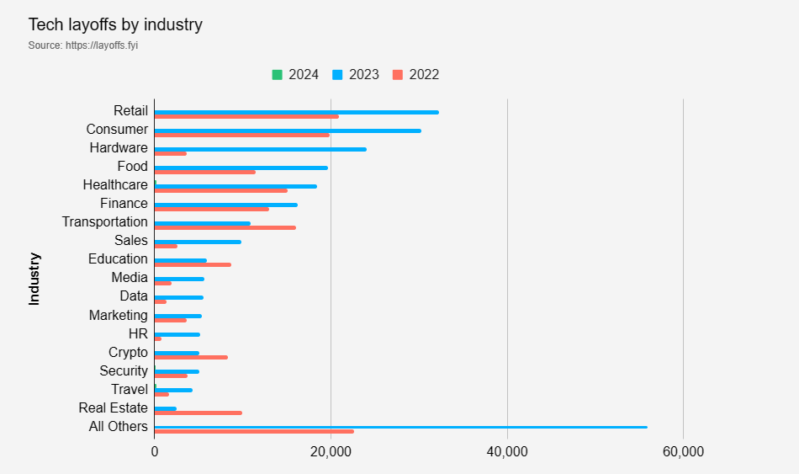

Figure 1: Layoff situation of industries by (layoffs.fyi, 2023)

There is a lack of a dedicated system to support teachers in observing and helping students during their internships. This shortage leads to delays in disseminating information, finding potential jobs, managing students without internships, and hindering the development of student's educational and career potential.

This project was carried out to solve these problems by designing and building an internship website system for the International University with a friendly, intuitive interface for students and teachers, thereby promoting communication and connection between businesses, teachers, and students. Successful development and implementation of the project is expected to optimize the internship process, bringing the best support results for students' internship process as well as management work for teachers.

## Scope and Objectives



### Scope

The scope of the project includes the implementation and development of a website to support students and teachers during the internship process.

This website will help facilitate connection, information sharing, and management. Scope includes:

* User segmentation: The website will meet the needs of each student, teacher, and website manager.
* Dissemination of information: The system will enable effective sharing of information, guidance, and resources related to internships.
* Accessibility: Ensure it is accessible to a wide audience across popular web browsers and mobile devices, ensuring broad usability.
* Task management: Implement features that support assignment, tracking, and management of internship tasks for both students and teachers.
* Connectivity: Provides tools for effective connection between students and teachers, fostering an environment conducive to instruction and feedback.

### Objectives

Main objectives of the Internship Website Support project:

* Ensure security and privacy: Implement robust security measures to protect sensitive information and ensure user privacy.
* Streamline the internship process: Create a clear and visual internship workflow. Make it easy for students and supervisors to track and manage internships.
* Simple interface: Design a simple and user-friendly interface that accommodates users with varying levels of technological proficiency.
* Scalability: Design the system to accommodate future growth and changing user needs by easily adding new features.
* Evaluate user experience: Continuously gather feedback to improve the application.

## Assumption and Solution



### Assumption

The website was built and developed with the purpose of supporting teachers and students during the internship process at IU, so there are some assumptions as follows:

* The website must be easy to see, and the pages must be intuitive and easy to navigate for each task for students and teachers.
* The website must be diverse and full of different features and resources for each user with different roles such as teachers, students, and admins.
* The website can be easily accessed via the internet with the most popular devices today.
* The website must solve the problem of continuous test tracking for teachers and students.

### Solution

Some solutions for website projects:

* Use minimalist designs for easy operation by students and teachers.
* Create functions to support exchange and connection between teachers and students.
* Create support functions for students during the internship process such as adding CVs, writing reports, ...
* Resource library with downloadable documents
* Create functions to help teachers easily observe and manage students during practice, such as progress tracking, etc.
* Promote the website to students and teachers through social media, email marketing, and other channels.

# CHAPTER 2

# LITERATURE REVIEW/RELATED WORK

Internships are a crucial and essential component in helping students apply their professional knowledge to the workplace and close the knowledge gap between academic study and real-world professional experience. As a result, to provide guidance, the website system that supports the internship process for teachers and students at international universities must investigate and evaluate the obstacles and problems that these parties encounter and develop various approaches to resolving those issues.



## Existing Platforms for Internship Support

Several platforms have been developed to address the difficult challenges of internships.

1. 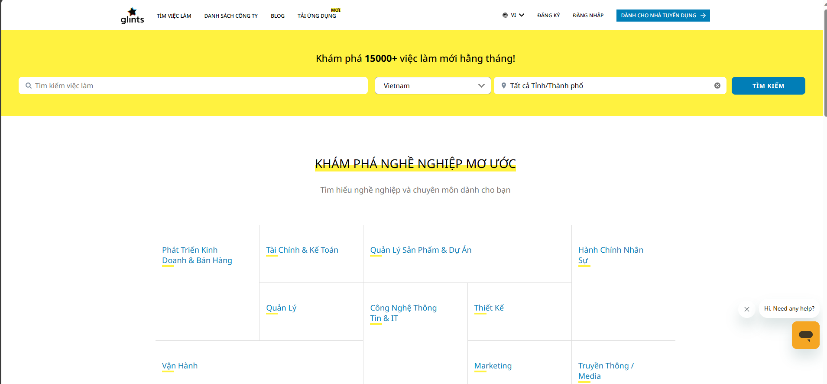

### Glints

Figure 2: web page glints

Glints is one of the leading job search platforms in Southeast Asia established in 2015 in Singapore and has supported more than 5 million talents and more than 60000 organizations (glints, 2015). Like most other job search platforms, there are functions to assist users in the job search and application process:

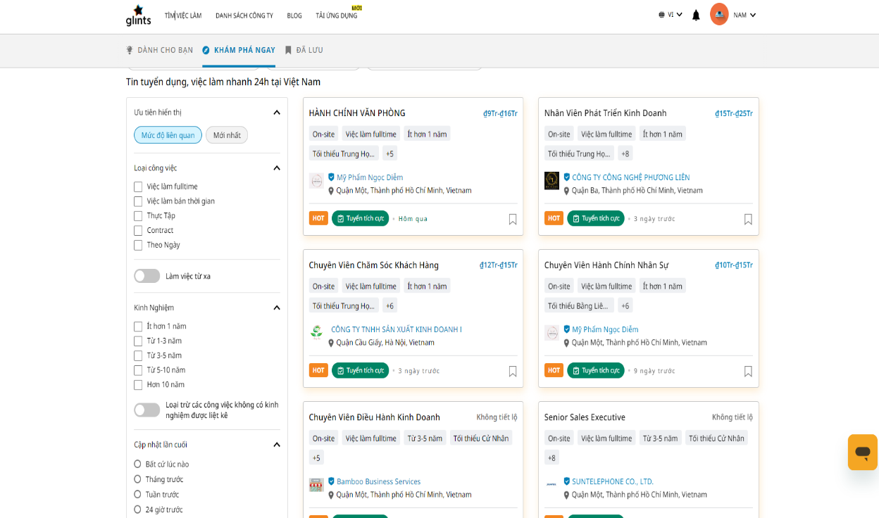- A special, intuitive interface is designed to help users easily grasp information about each job and company.

Figure 3: Job Page of Glints

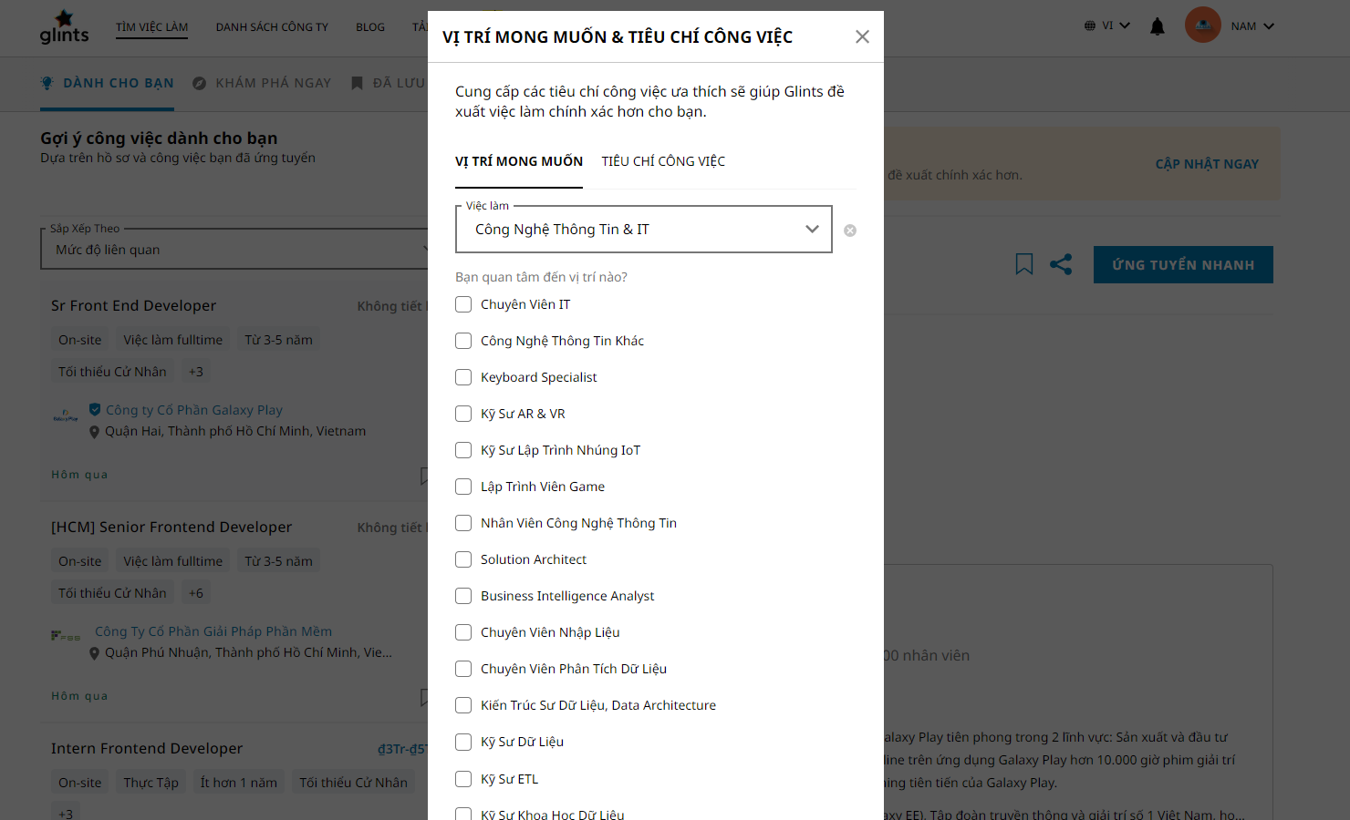-There is a recommendation feature based on keywords about the job field that the user wants when initially registering.

Figure 4 Recommend register of glints.

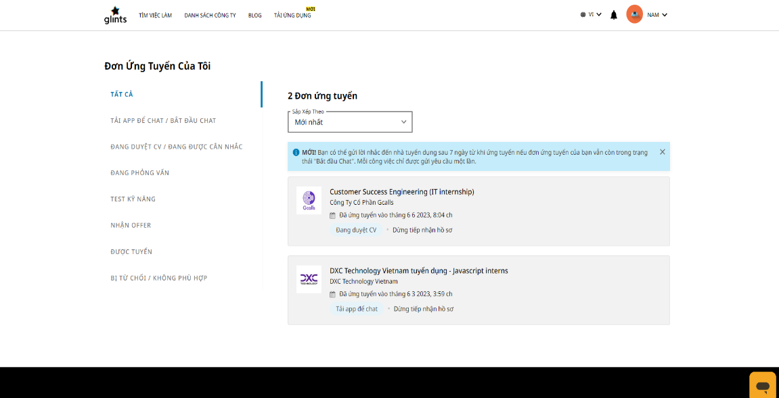- Enhance and support users' job application work has a notification feature and checks the application process according to different statuses, for example, CV review, interview, qualification test, receive.

Figure 5: Glints view Apply.

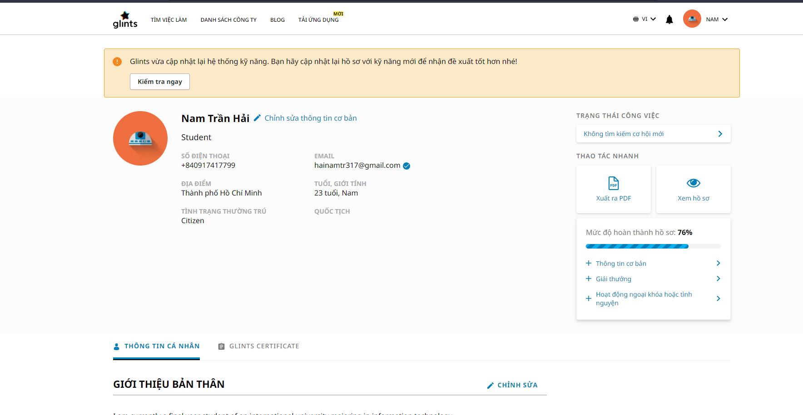- Ability to customize personal information: Profile information for applying can be freely customized to help users express all the necessary information to employers.

Figure 6: User Information of Glints

### A screenshot of a computer Description automatically generatedLinkedIn

LinkedIn is the world's largest professional network, with more than 1 billion members worldwide, which was founded in 2003 (LinkedIn, 2003). The platform was developed to connect professionals across industries, find jobs, and User's career development.

Figure 7: LinkedIn home page

Some stinging aspects of LinkedIn:

* Sharing information and content: Users can freely share articles, videos, personal emotions, etc. with people connected to them on the network.

Figure 8: blog page of LinkedIn

* 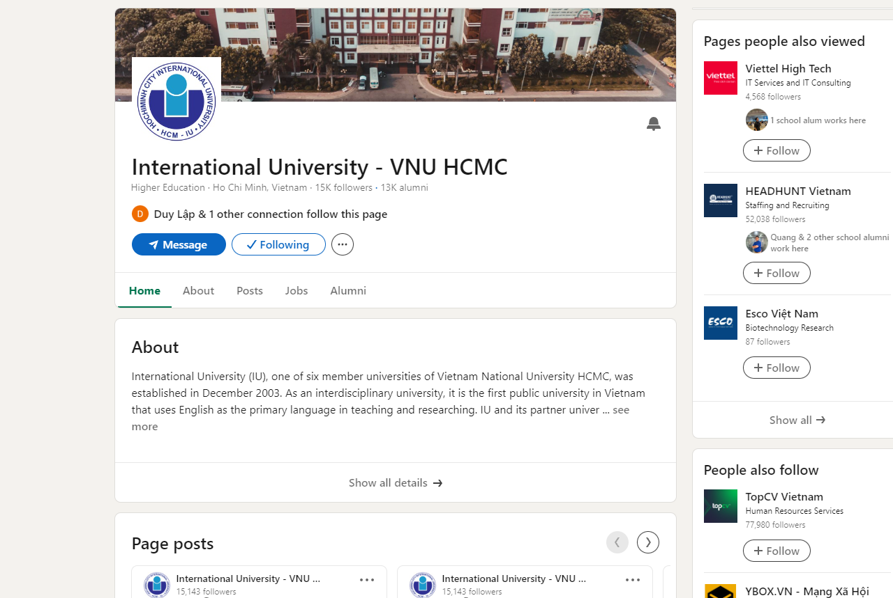Create Profile and Company Pages: users and businesses can freely create personal pages with a variety of information such as education level, work experience, skills, recruitment information, etc.

Figure 9: User page in LinkedIn

* 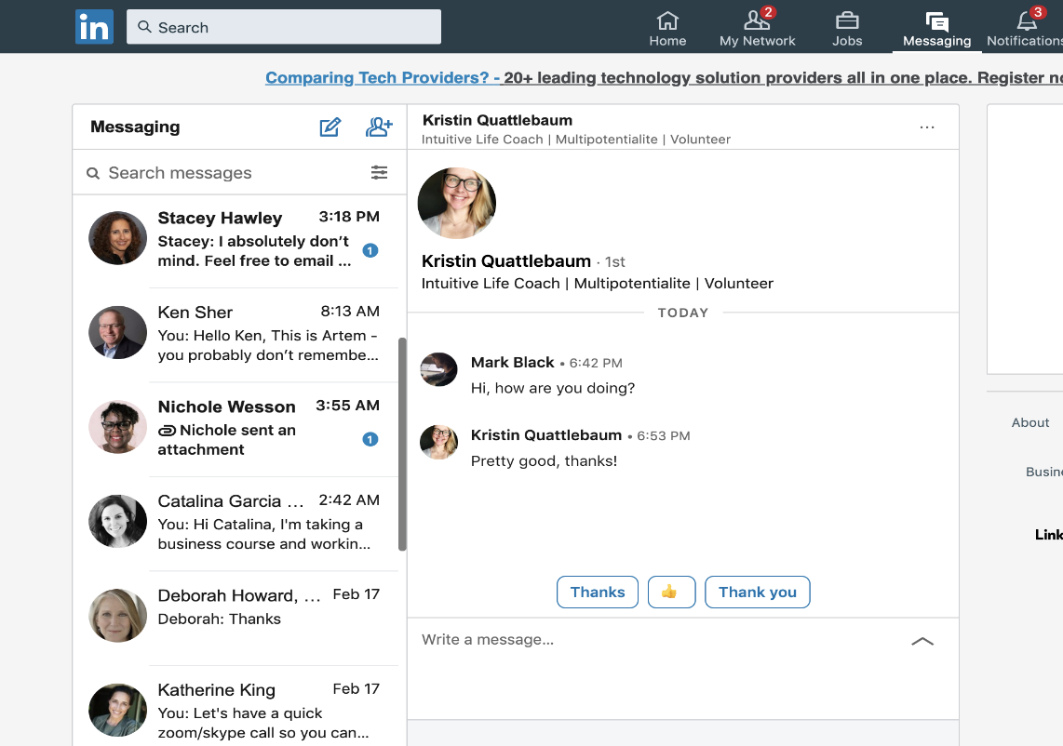Communication: Users can communicate with their connections through LinkedIn's messaging system. This is often used for professional inquiries, employment opportunities, or collaborations.

Figure 10: Chat page LinkedIn

* Job search: LinkedIn allows businesses to post information about the jobs they recruit, and users can search and find the desired job through it.

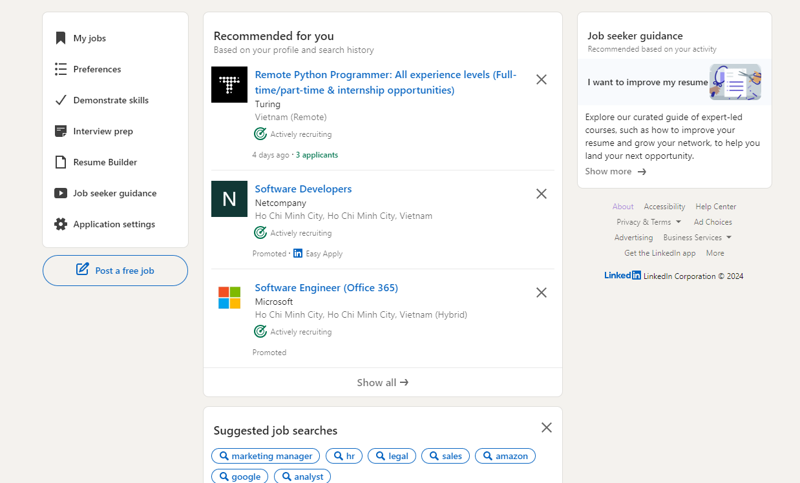

Figure 11: Job search page LinkedIn

### IU Job Hub

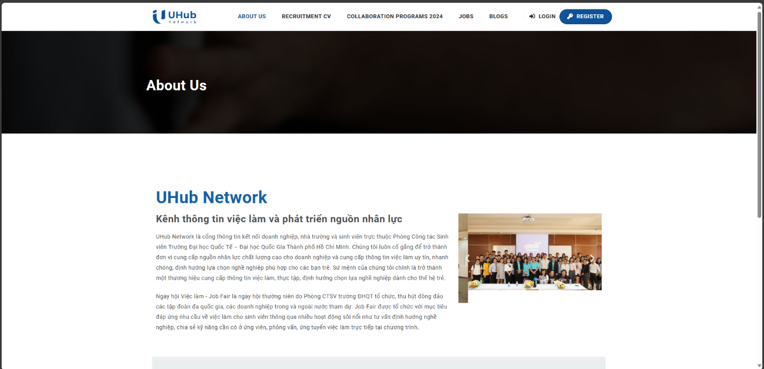IU Job Hub is an information portal that shares and connects international university job issues.

Figure 12:Job Hub

There are some basic and outstanding functions as follows:

* Recruitment CV: Used to register information to send to employers.

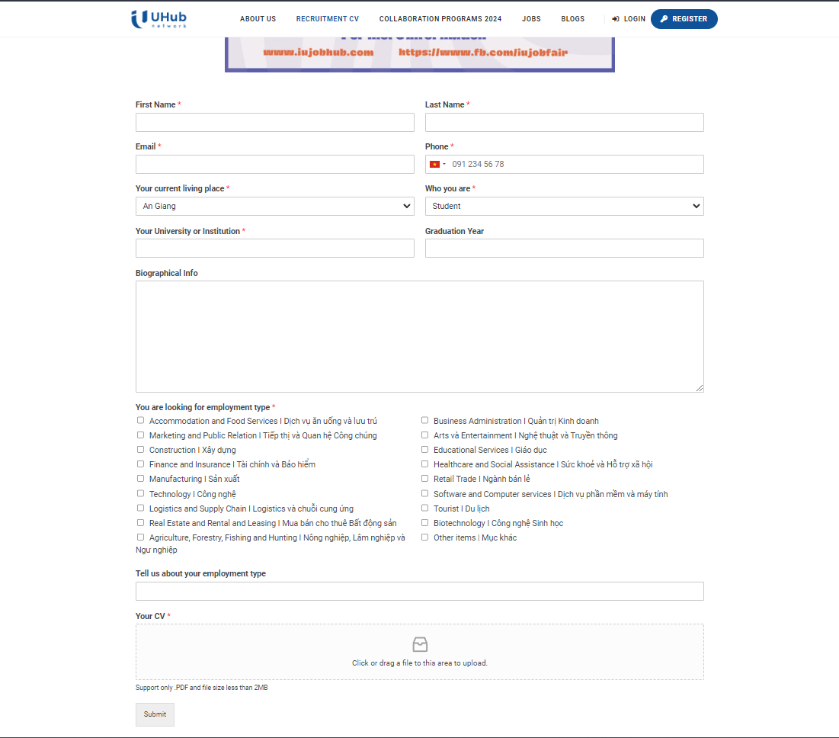

Figure 13: Form recruitment Job hub

* 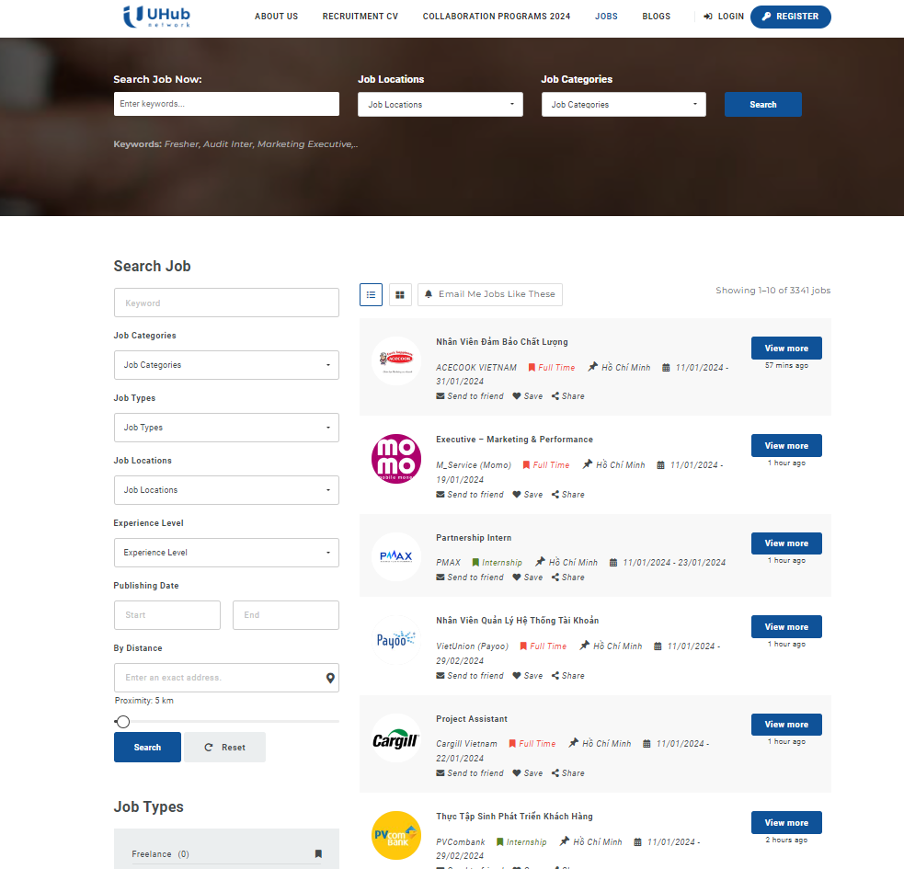Find Jobs: Platform that allows you to search and apply for jobs with a simple, intuitive interface.

Figure 14: Job Page of Job hub

* Blogs: The platform also shares festivals as well as program information of businesses connected to international universities.



Figure : Blog of IU Hub

### Analysis and Evaluation

A brief review of the mentioned functions of these currently available platforms, although very complete in many aspects, however for this project, it only meets the needs of finding jobs for students, with Support for the ability to connect teachers, students, and businesses, but assessment management is not yet available to support teachers.

## Challenges of students during the internship process.

Internships are an opportunity for students to experience and interact with social reality, thereby gaining more experience in professional and personal development after graduation. Along with that, the internship process of students in general and IU students in particular has different difficulties.



### Difficulty accessing information sources.

At IU there are many different sources of information, both official and unofficial, such as BLACKBOARD, Edusoftweb, job Hub, Facebook fan page, ...

 

 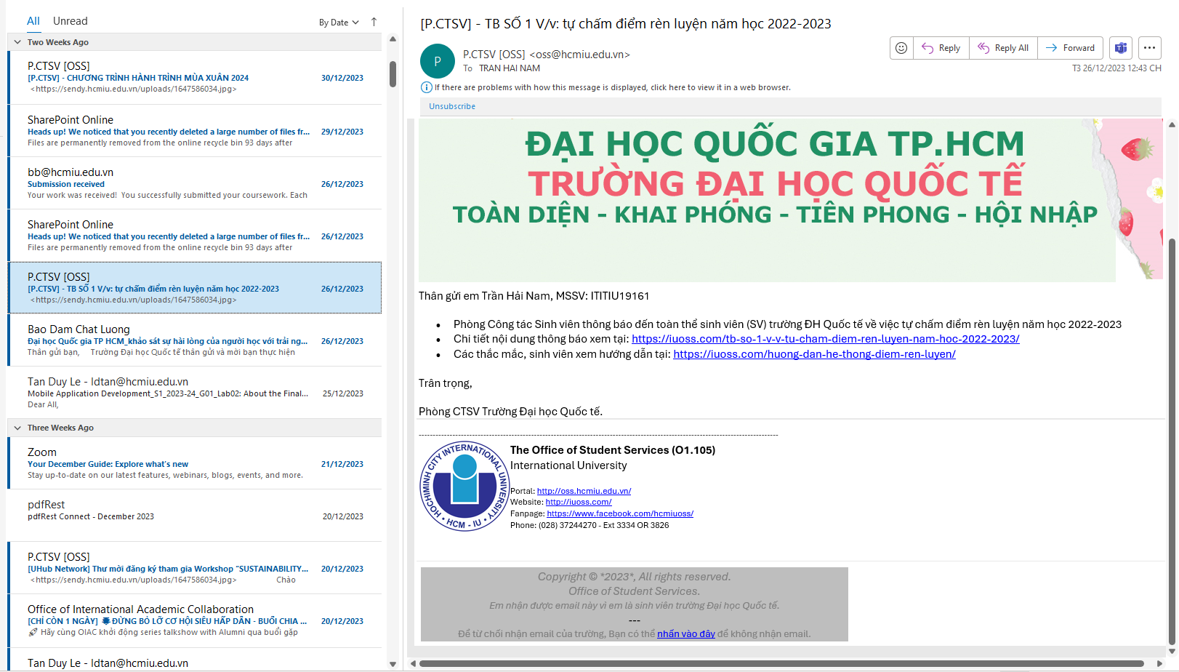

Figure 16: Information diversity

It is the diversity of information sources that makes finding experiences or internship processes at school more difficult and unreliable. Students lack the necessary information to prepare for the internship process, which can prevent students from being able to prepare and keep up with the school's set schedule and the school's regular internship period. It takes place in the summer very quickly, only about three months to complete everything from finding an internship to submitting a report. So this project is to develop a platform that can centralize information into a single official information page that shares the school's internship process so that students can be thoroughly prepared for the internship at IU.

### Difficulty in finding internships.

According to the analysis in the article UEH's student care and support department, ((DSA), 2023) the impacts of post-COVID as well as the current stressful situation in the European region have had a strong impact on the economy. The impact and wave of layoffs is strong everywhere in the world, including Vietnam, which is also affected, causing a surplus of highly qualified labor and that creates difficulties for students who want to Intern as well as students about to graduate who do not have much experience. To solve that, the school should also have business connection programs to support students with more opportunities in finding internships and this platform will be a bridge to support students in finding internships. there.

### Lack of soft skills and connection with teachers

Some necessary skills for students to be able to find jobs such as writing CVs, sending emails, interviewing... students often lack these necessary skills to be able to apply for jobs. However, the most difficult thing is to determine the certainty of those skills so that students can confidently apply themselves for the jobs they want. This requires the support and confirmation of the teacher. she instructed. A platform that provides knowledge information for these skills and connects students and teachers so that teachers can support and validate student progress is a necessity.

## Teachers' disadvantages and difficulties in supporting students.

Teachers at IU have difficulty managing students because they lack a platform to track student progress during the internship process so they can proactively support students. Some processes teachers need to support students include finding jobs, writing CVs, and writing reports.

The teacher's grading process also has difficulty synthesizing and checking each person's progress.

A platform that supports teachers in these processes is something that can reduce the workload and pressure on teachers, thereby helping teachers better support students and improving work productivity for teachers.

## Security and privacy concerns in educational support websites.

The rapid development of technology comes with the risk of personal information being exposed, and a survey found that 82% of people shared that the organization they work for has experienced at least one data breach digital conversion (Tùng, 2022).

Therefore, applying security features is necessary and a priority for every platform today.

Authentication issues with all access, minimizing third-party support, etc. are necessary issues for the platform to avoid the possibility of outsiders entering the system and stealing your data. students and teachers for personal gain.

## JavaScript for web development



Figure 17: JavaScript

JavaScript is a powerful programming language for website development invented by Brenda Eich. (hamiswillee,Cybersharph , 2023). The survey shows that JavaScript is considered the most popular language, used by many users 63.61% compared to other languages. (stackoverflow, 2023).

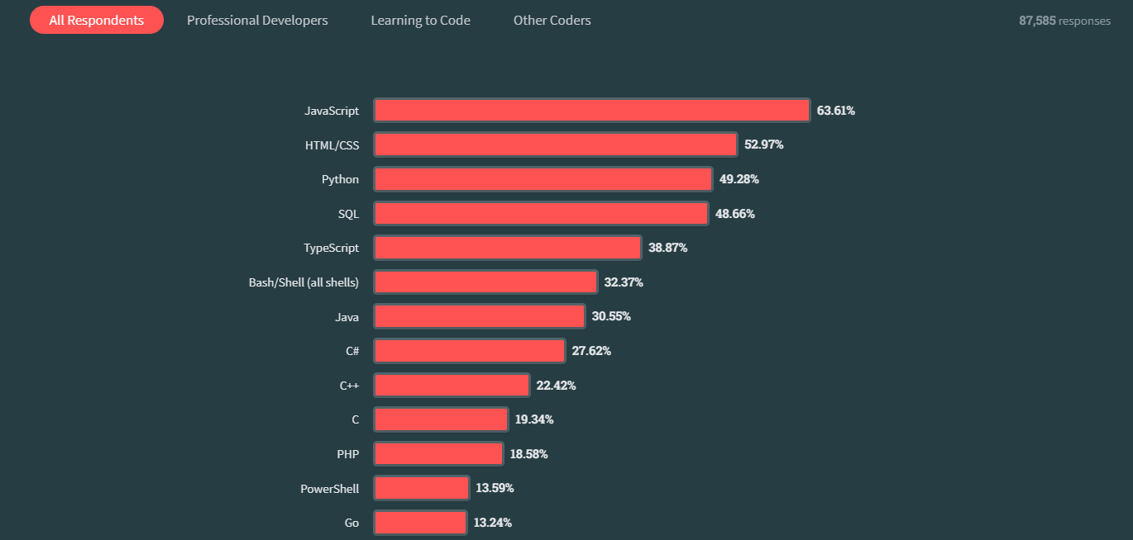

Figure 18: Data survey of stack overflow 2023

JavaScript is a language used to develop websites with JS that can turn a static website into a dynamic website with different functions. JavaScript supports many programming paradigms such as object-oriented, procedural, and functional programming. Some concepts and capabilities in JavaScript such as closures, primitives, and asynchronous programming are elements of JavaScript, which makes JavaScript popular in web programming.

About Frameworks and Libraries:

JavaScript has a long history of development, so there are many different frameworks and libraries to assist in website development. Some outstanding support frameworks and libraries include:

Front end: React, Angular, Vue.js

Back end: Nodejs, express,

JavaScript for web development shows its dynamic evolution from a scripting language to the foundation of modern web applications. Researchers and developers continue to explore features, and best practices, and expand its ecosystem, providing valuable insights to developers in the ever-changing web development landscape.

## Nodejs



Figure 19 Nodejs logo

NodeJS is an open-source JavaScript runtime environment and does not depend on any operating system so it can be developed on any type of computer on the market today (Semah, 2022). Nodejs is often used to run and build backend systems due to its several advantages:

* Asynchronous event-driven IO, allowing multiple requests to be processed concurrently.
* Use JavaScript – an easy-to-learn programming language.
* Allows streaming of large files
* Actively supportive community

## What is npm?. What is npm and what does it stand for? | by Damini Varu | MediumNode package manager (npm)

Figure 20 NPM

Npm is a tool that comes with NodeJS that manages packages, supports installation, downloads libraries to support system development using NodeJS, and registers and creates NodeJS projects for developers (Metwalli, 2023).

Some of the benefits npm brings to users:

* Reusability: Being open source, anyone can use any package on npm to build personal projects.
* Support: Since there are so many developers using npm, this can also be a co-development community from which support users can help each other manage bugs and develop.
* Dependency management: It is a way to handle and manage dependencies effectively when working on large projects, especially when developers don't live in the same country.

## Express.js



Figure 21 Express

Based on the content in the shared article (Sharma, 2023). Express is a NodeJS-based framework that provides built-in functions to support building applications for web and mobile devices.

Express features provide great support in backend network development, for example:

Middleware: Middleware is a request handler that has access to the application's request-response cycle.

Routing: refers to how the URL of an application's endpoint responds to client requests

Debugging: Express makes this easier because it pinpoints the part with the error

How Express Works:

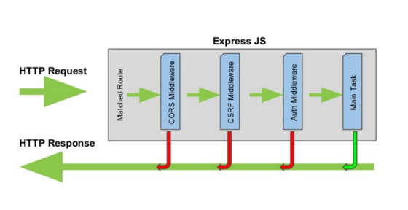

Figure 22 Express work

Through a comparison of how taking orders in a restaurant operates, we provide an express operating process that can be understood and used for backend development (Kononenko, 2017). The way express works is to receive requests to perform server-side functions that the client side puts through screening steps that return different results to the client.

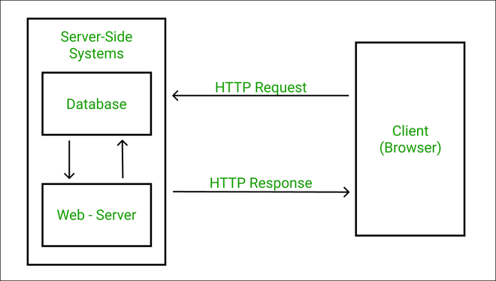

Figure 23 Structure of web

## Vite



Figure 24 Vite

Vite is a tool that helps developers create and grow new projects and solves some of the challenges in front-end web development with the following features (Refine, 2023).

* Support for native ES modules: Vite improves overall performance allowing for fast startup and increased storage capacity based on the characteristics of the native ES module instead of having to package the modules during development Vite uses the browser's native capabilities to load native modules as separate files (Refine, 2023).

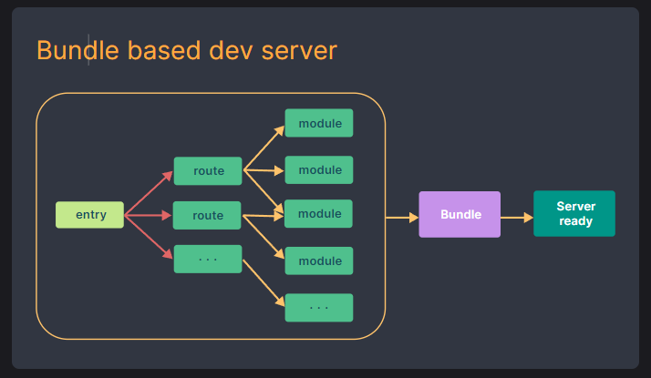

Figure 25 Vite dev server

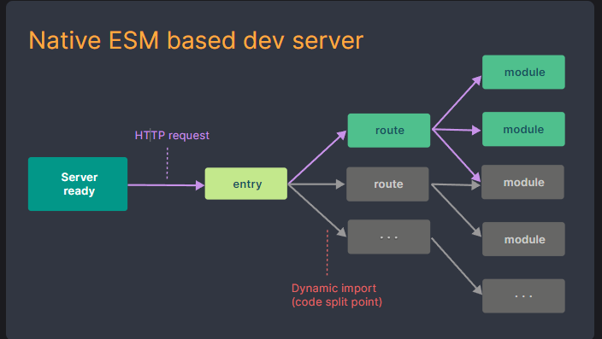

Figure 26 Vite ESM

* Fast build process: ‘esbuild’ is famous for its outstanding speed, capability of creating optimized encoding packages, and fast packaging ability compared to traditional packaging, which Vite takes advantage of to help with deployment productivity (Refine, 2023).
* Code separation and lazy loading: Vite supports code separation and lazy loading. This helps the system to only load the necessary content and load separate parts, thereby reducing loading time and increasing user experience (Refine, 2023).
* Hot Module Replacement (HMR): HMR can track changes in the model and replace it while the application is running without having to reload all the application's modules. (Refine, 2023)

## React



Figure 27 React.js

React is an open-source library developed by Facebook to support front-end development, used by large technology companies for Facebook, Netflix, WhatsApp, etc. (Hai G, 2020). Some features of React help the library to be chosen by up to 40.58%, ranking second in the survey after NodeJS (stackoverflow, 2023).

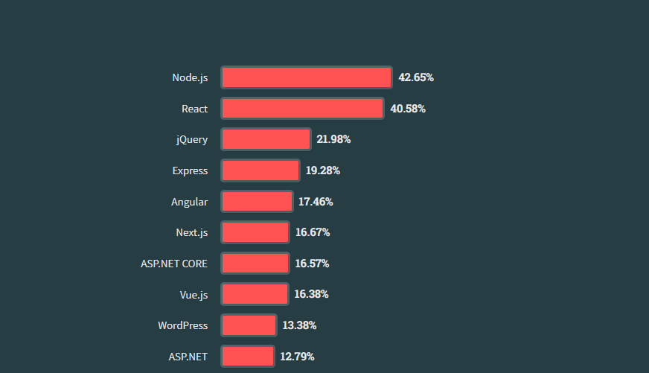

Figure 28 data Survey for front end of Stack overflow (2023)

Easy to use and learn: React is an open-source code developed from the JavaScript language, so just knowing about JavaScript is easy to use and access.

Reusability: React has a special structure that allows developers to reuse components, thereby reducing the workload for developers.

## MongoDB



Figure 29 MongoDB

MongoDB is an open-source NoSQL database used for storing large amounts of data. NoSQL Instead of using tables and rows as in the traditional relational database of SQL database, MongoDB uses Use collections and documents (Pedamkar, 2023).

MongoDB has the similar structure as RDBMS, a commonly used database structure, and uses the BSON format to store documents. (Pedamkar, 2023)

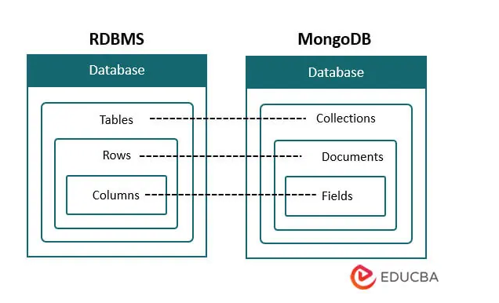

Figure 30 Comparation MongoDB and RDBMS

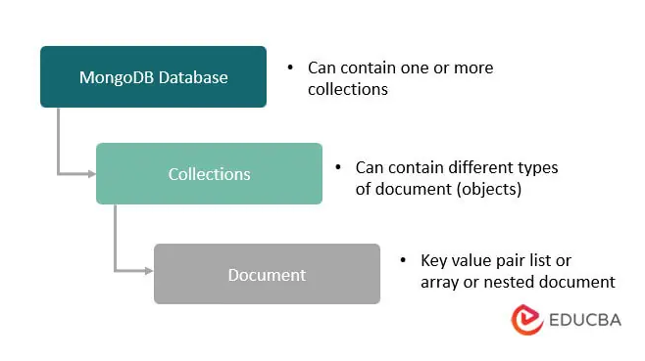

Figure 31 MongoDB structure

Some application functions use MongoDB:

* Real-time differentiation: MongoDB has a low delay per second which allows data analysis to be updated and tracked quickly (Pedamkar, 2023).
* Product Catalog: with a dynamic schema that allows for accurate filtering of keyword-related records (Pedamkar, 2023).
* Scalability and dynamics: MongoDB can store a variety of data in different forms to help the subsequent development of the application in having to collect data from a variety of sources (Pedamkar, 2023).

## A screenshot of a computer Description automatically generatedMaterial UI(MUI)

Figure 32 MUI

MUI is an open-source library of React components supporting the design and construction of the interface (UI, 2023).

Some advantages of MUI (UI, 2023) :

- Beautiful by default: Developed and design recognized over the years guaranteeing conformity to the standards of form.

- Customization: Allows customization of the walls according to personal preferences to have distinction in the applications of the developer.

- Reliable community: MUI has a long history of development in the React ecosystem so MUI's collaboration is very confident in supporting and developing.

## Redux

Definition:

“**Redux is a pattern and library for managing and updating application state, using events called "actions".** It serves as a centralized store for state that needs to be used across your entire application, with rules ensuring that the state can only be updated in a predictable fashion.” (Redux contributor, 2023)

Figure 33 Redux

In a large program there will be many different application states in many different places that need to be exchanged to get information from each other or continuously updated states then Redux is the most effective solution to solve those problems.

Figure 34 Redux workflow

How redux works

At the user interface provide actions to perform redux actions designed by the developer to send new data changes that need to be updated. When this updated state arrives at the storage area, it will take the same state assign a new state change, and then update the data to the interface.

## Axios



Figure 35 Axios

Axios is a JavaScript library that supports sending HTTP requests from a server or web browser (Kollegger, 2018).

Axios functions:

* Create XMLHttpRequest and HTTP requests.
* API support promised.
* Automatically handles Json data conversion.
* Setting bandwidth limits

## Docker



Figure 36 Docker

Docker is a platform designed to make it easier to create, deploy, and run applications using containers. Containers allow developers to package an application with all the parts it needs, such as libraries and dependencies (Dokcer, 2023)

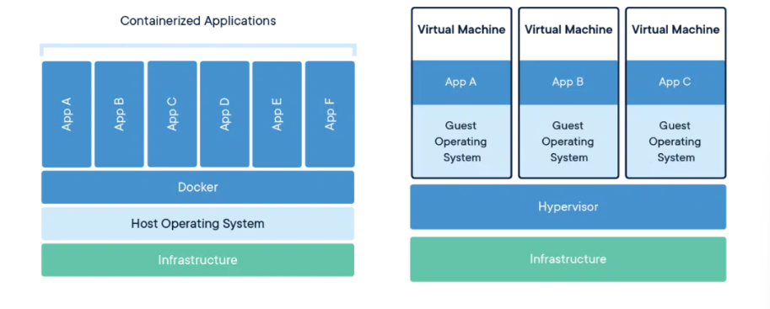Docker is a new way to change the way large system programs are run. Instead of having to create different virtual machines with separate operating systems that take up a lot of resources and space, docker shares the machine's operating system kernel, making the system lighter and easier to manage while reducing error rates. due to different machine environments.



### Container

A container is a standard unit of software that packages code and all its dependencies so that an application runs quickly and reliably in any number of different machine environments. The conditions and components to run the application such as code, runtime, system tools, libraries, etc. are packaged into a Docker engine image. (Docker, 2023)

## JSON Web Token

An open standard called JWT (JSON Web Token) (Poddar, 2022) offers a standardized way for data to be safely and consistently transferred between parties using JSON objects. Authentication and authorization in online services and apps are among its main use cases. The three primary components of a JWT are the Header, Payload, and Signature. Information about a JWT's type and the cryptographic algorithm—such as RSA or HMAC—used is contained in the header. The data to be delivered, such as user details, access rights, and other optional data, is stored in the payload.

Encoding is commonly used in JWTs to transform data in both the header and payload portions. If users have access to JWT, they can easily decode the encrypted data to obtain the original information. It is therefore advised to refrain from putting sensitive information in these parts. The data is not meant to be encrypted or secure by the JWT encoding method, such as Base64Url encoding. Its primary goal is to guarantee the token's efficient and reliable transfer. It makes it possible to express binary data in a way that makes it transferable between various systems with ease. Last, the Signature is a string created by utilizing a secret key specific to the token to sign the Header and Payload. Verifying the integrity and authenticity of the token is the goal of the signature.

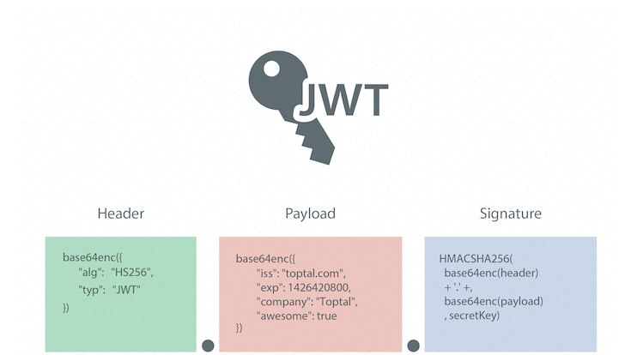

Figure 37 JWT

The workflow with JWT typically involves the following steps. Users log in with their credentials (username, email, password, and so on). The server verifies the login information and generates a JWT (JSON Web Token), which is then sent back to the user. The user includes the JWT in the Authorization header of subsequent requests to the server. Upon receiving a request, the server verifies the authenticity and integrity of the JWT by checking its signature and decoding the payload. The server utilizes the information in the payload to authenticate and authorize the user, granting access to the requested resources or services.

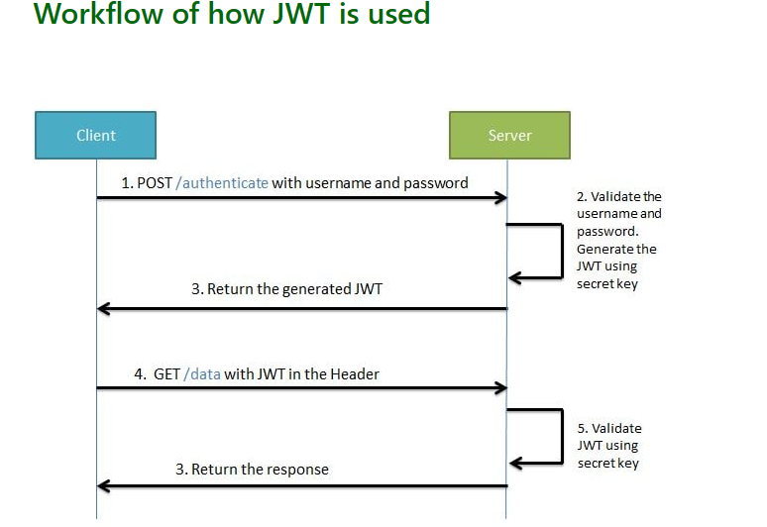

Figure 38 Workflow JWT

## Conclusion

In summary, the literature review established a solid foundation for the Web Support Internships for Students and Teachers project. By integrating insights from existing research, the project not only aligns with established best practices but also demonstrates a forward-looking approach, positioning it as a promising effort poised to make significant contributions to the field of educational technology and internship program optimization.

# CHAPTER 3

# METHODOLOGY



## Overview

Through analyzing the internship process from the beginning and end at the international university to provide reasonable and practical solutions to handle and support students and teachers, thereby can improve productivity.



## Requirement analysis



### User requirements



### Student requirement analysis

User Authentication and Authorization: Create a Login page. The student accesses the web use their student account and web app will redirect to student page.

Jobs list: The website should have a list of internships available for students (This will show in center home page), which should include the job title, company name, job description, location, and application deadline.

Company profiles: The website should allow companies to create a profile, which should include information about the company, its mission, vision, and values, and a list of current jobs they hire.

Communication tools: The website should have a built-in communication system that allows students and companies to communicate with each other regarding the application process. The students can also communicate with their teacher and instructor on this website.

Writing Curriculum Vitae (CV): The website supports creating CV forms for students to fill out and save in the system. Students also upload their personal CV on page CV.

Application process: The website should allow students to apply for internships by submitting their CVs and cover letters. The application should also include a form that captures the student's personal details such as name, email address, phone number, and educational background.

Notifications: The website can send notifications to students when a new internship is posted that matches their preferences and notify companies when a student applies for one of their internships. The website also sends notifications to teachers when students change their status of having received or completed an internship.

Chat: The website provides a chat method for students to communicate with their teacher and instructor.

#### Teacher requirement analysis

User Authentication and Authorization: The teachers will use accounts which are provided by the school to login to this web app.

Manger Student: The website supports Teachers to see all the students they manage. Teachers can visit the student page to view their CVs and make suggestions for students' CVs.

Dashboard: The website should provide a dashboard for students and teachers to keep track of student’s applications and the status of their applications.

Grading: During the time before the internship period ends, the website will send a notice to students for students to submit internship reports and teachers based on that to give student grades. Websites have a page for Teacher view again and edit after that they can export it to submit for school.

Notifications: The website will send notifications to Teacher when the students apply a job or register their instructor.

Chat: The website will provide a chat box for teachers to communicate with students.

Report form: website also provides list of report form for teachers make report.

#### Admin requirement analysis

User authentication and authorization: The admin must use an admin account to be able to log in and use website functions as an administrator.

Dashboard: The management page needs to see all information most intuitively, this helps a lot in management.

User management: The admin is the person with the highest authority so can monitor and control users. Has full functions such as adding, deleting, editing, etc.

Content management: All content displayed on the admin website must be able to be added or modified.

### System requirements

For a website to be used comfortably in schools, not only the software but also the hardware to run the website needs to meet the following requirements:

Server Hardware:

* Processor (CPU): Multi-core processor with high clock speed to handle concurrent requests efficiently.
* Memory (RAM): RAM is enough to support the load and avoid bottlenecks when the number of users increases.
* Storage: Use fast and reliable storage, such as SSD, to ensure quick data retrieval.

Scalability:

* Load balancing: The system should implement load balancing to distribute traffic evenly among multiple servers.

Security Measures:

* Security System: Deploy a firewall to filter malicious traffic and secure servers from cyber-attacks.
* SSL/TLS: Uses security protocols for data transmission, such as HTTPS.

Network Configuration

* High bandwidth: Ensure enough network bandwidth to handle incoming and outgoing server traffic.

Backup and Recovery: Implement automatic data backup function to avoid losing student and teacher data systems.

Web Server Software: Choose the right type of management software to increase system performance.

## System Design



### User Interface design

#### Workflow of Users

On the website, there are two main user groups: students and teachers, each with its own specific goals. The project is designed to fit the daily tasks these users perform during their IU (International University) internships simplifying the key steps performed by both groups, for allowing us to incorporate practical features that serve their needs. In addition to students and teachers, it is equally important to enhance the organizational and data management aspects for administrators. Therefore, we analyze the manager's workflow by focusing on the current output in the web system.

##### Students’ workflow:

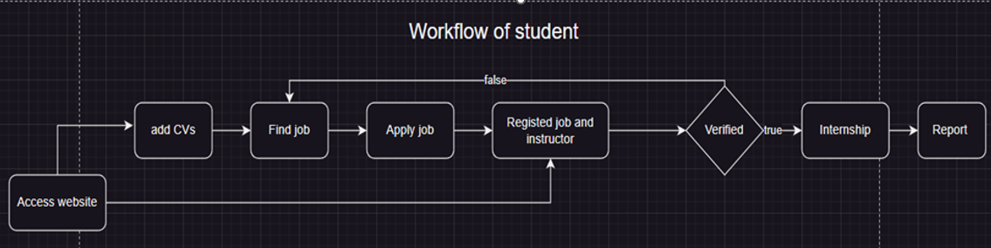

Figure 39 Student workflow

The main purpose of students will be to use the website to search for intern jobs that the school has selected and introduced on the web. Before applying for a job, students must submit a CV. When students apply for a job, they will send their CV and cover letter by email and have it signed by the school. The process of applying for internship jobs will take place according to the company's process.

When the job application is successful, students will go to the website to register according to the sample forms. The registration information will be sent to the teacher for confirmation. After being confirmed by the teacher, the internship will take place according to the company's side. When the internship is nearing its end, the school will automatically send a notification to the students to switch to report writing status. Students will send a report to the teacher and finish the internship.

##### Teacher workflow:

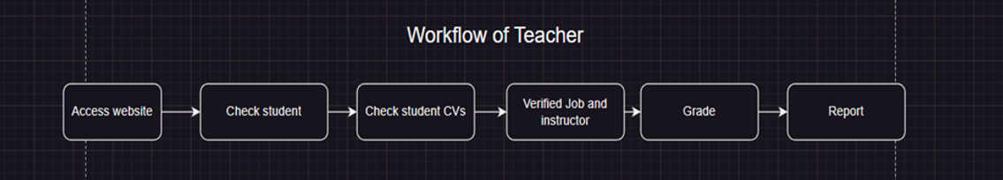

Figure 40 Teacher workflow

In the role of a teacher, there is an important responsibility in managing students and evaluating their internship results. This process involves thoroughly checking each student's details, including their CV exam information, which can be accessed through individual student pages. When students apply for jobs, teachers play an important role in affirming the authenticity and quality of their work.

After completing the practice task, the teacher evaluates and scores the student's overall achievement. This grading process makes it difficult to synthesize data so that teachers can have a thorough assessment of the progress and quality of student practice. This grading process serves as a comprehensive summary, providing valuable insights into students' abilities and performance during their internships.

The teacher is then responsible for drafting a final report to submit to the school. This final report summarizes the entire internship process, giving an integrated view of the student's progress and contributions. By documenting student achievements and growth throughout the internship, teachers contribute to a better understanding of students' real-world skills and application of knowledge in real-world settings. international. This thorough evaluation process ensures a comprehensive evaluation of the student's internship, contributing to an enhanced overall educational experience.

##### Admin workflow

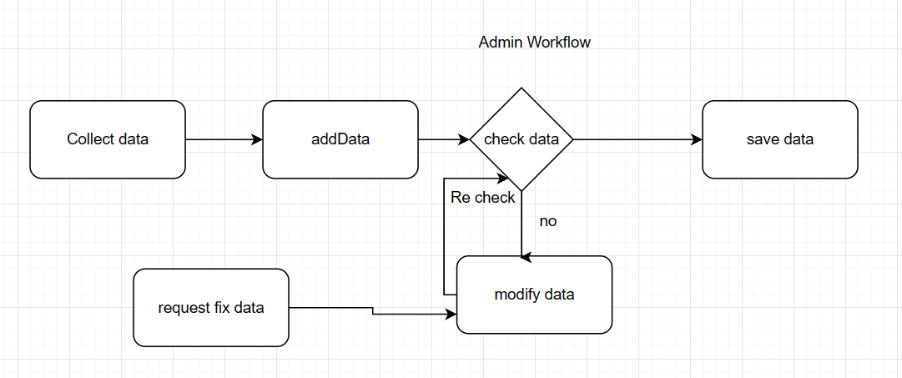

Figure 41 admin workflow

As for the administrator role, it plays an important role in adding and removing content to the website and handling tasks related to the system's data. The admin's job starts with receiving and collecting data related to the website's content such as corporate and business cooperation jobs, and specific user information such as students and teachers.

After synthesizing the necessary data, it will be added or removed and entered into the system according to pre-made templates. This process requires accuracy to provide accurate information to students and teachers while using the web system for the internship process.

Next is to check the entered information. If there is a case of incorrect information being entered, changes will be made. In addition, when there are requests from users as well as businesses to correct personal information. The individual will also perform the editing task. After the editing is completed, it will be carefully rechecked, and the work will be done to save information. This work will be carried out continuously and automatically in the web system to ensure Data is not lost during data entry.

#### Use case diagram.

Based on some requirements and analysis of the website. The Internship IU web app will have 2 main actors are students, teachers and extra actor is admin.

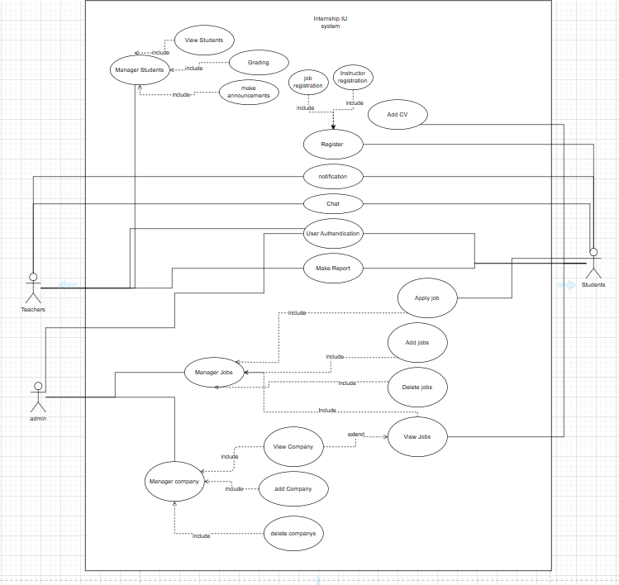

Figure 42 Use Case Diagram

Following the structure and function of the use case diagram of the analyzed system, the project will include many different small functions to synthesize into large functions to support all aspects of users during the process internship program at international universities.

* + - * 1. Use Case descriptions:

**Use Case**: 1

|  |  |
| --- | --- |
| **Name**: | User authentication |
| **Actor**: | Students, Teacher, Admin |
| **Inputs**: | UserId and password |
| **Outputs**: | Login successfully and show page flowing role User |
| **Scenario**: | The user enters an account including UserId and password. This information will be sent to the system to authenticate the information and return a token containing the user's information. After successful authentication, the system will move the user page to a new page depending on the role of the account the user is logging in to. In case an error cannot be authenticated, the system will report an error to the user to handle the error. |
| **Precondition**: | Authentic accounts are provided from the school. |
| **Post condition:** | Users are redirected to the page according to their role and receive a token to authenticate their identity for site operations. |

**Use Case**: 2

|  |  |
| --- | --- |
| **Name**: | Register |
| **Actor**: | Students |
| **Inputs**: | Information according to the registration form |
| **Outputs**: | Update database of student |
| **Scenario**: | Students submit registration information according to the pre-created form and send that data to the system. The system will check and authenticate the user's account and perform functions to change information for students.  If successful, a success notification will be sent. If necessary, information is missing, the student will be notified of failure and the data will not be updated. |
| **Precondition**: | Students submit the necessary information to the system |
| **Post condition:** | Complete database queries |

**Use Case**: 3

|  |  |
| --- | --- |
| **Name**: | Make report |
| **Actor**: | Students, Teacher |
| **Inputs**: | File upload |
| **Outputs**: | Store file and update the database |
| **Scenario**: | Users submit files to the system. The system will check student information and store it, and the system will send back the path to the stored file. This path will be saved to the database of the User submitting the request. After completing the steps, a completion notification will be sent to the user. |
| **Precondition**: | Users send file |
| **Post condition:** | Store on server and update database |

**Use Case**: 4

|  |  |
| --- | --- |
| **Name**: | View Jobs |
| **Actor**: | Students |
| **Inputs**: | none |
| **Outputs**: | List jobs |
| **Scenario**: | Students log in to the website and go to the jobs page. The system will send back all the jobs it has for students to choose from. |
| **Precondition**: | Students must log in to their student account issued by the school. |
| **Post condition:** | Show list Jobs. |

**Use Case**: 5

|  |  |
| --- | --- |
| **Name**: | Apply Job |
| **Actor**: | Student |
| **Inputs**: | Student information and Job id |
| **Outputs**: | Send mail and store job in database of student |
| **Scenario**: | Students press the apply button with necessary information such as CV, introduction, and Job id for the system. The system will verify the information and email the student's information to the business. When successfully submitted, students will be notified, and the applied jobs will be saved in the database. |
| **Precondition**: | Registered students have the necessary information to apply |
| **Post condition:** | Database update success and send email. |

**Use Case: 6**

|  |  |
| --- | --- |
| **Name**: | Notification |
| **Actor**: | Student, Teacher |
| **Inputs**: | none |
| **Outputs**: | Send notifications to the correct target audience |
| **Scenario**: | After important activities, the system will support sending notifications to the users who need to send them. For example, a student registers for an instructor or a job. The teacher in charge of that student will receive notifications about that student's activity. |
| **Precondition**: | Complete important changes |
| **Post condition:** | Notification successfully sent to the user. |

**Use Case: 7**

|  |  |
| --- | --- |
| **Name**: | Chat |
| **Actor**: | Student, Teacher |
| **Inputs**: | UserId, message |
| **Outputs**: | Store messages in the database |
| **Scenario**: | Students and teachers send messages to each other. The data is collected by the system and saved into the database. Students and teachers can see their messages on the system. |
| **Precondition**: | User must be logged in. |
| **Post condition:** | Message data is saved |

**Use Case: 8**

|  |  |
| --- | --- |
| **Name**: | View Students |
| **Actor**: | Teacher |
| **Inputs**: | none |
| **Outputs**: | List Students |
| **Scenario**: | Teachers successfully log in to the site and require the system to display all the student information that they manage. The system receives requests from the user side that the teacher will check and take all the information to send to the teacher and display up. |
| **Precondition**: | Teach login with account role teacher |
| **Post condition:** | System display list students. |

**Use Case: 9**

|  |  |
| --- | --- |
| **Name**: | Grading |
| **Actor**: | Teacher |
| **Inputs**: | StudentId, Grade |
| **Outputs**: | Save grade in database |
| **Scenario**: | The teacher enters and sends a student's scores to the system. The system receives information and performs checks and saves score information into the student database. |
| **Precondition**: | Teachers must log in and open the student information page to grade |
| **Post condition:** | The system successfully saves points to the database. |

**Use Case: 10**

|  |  |
| --- | --- |
| **Name**: | Make announcements |
| **Actor**: | Teacher |
| **Inputs**: | StudentId, content announcement |
| **Outputs**: | Send announcement to students |
| **Scenario**: | Teachers enter the form to send notifications to each teacher with the content to send. The system will receive authentication information and save it into the system and send a notification to the correct student. |
| **Precondition**: | Teachers must log in and open the student information page |
| **Post condition:** | The system sends a notification successfully. |

**Use Case: 11**

|  |  |
| --- | --- |
| **Name**: | Add Jobs |
| **Actor**: | admin |
| **Inputs**: | Information of Job |
| **Outputs**: | Have new Job in database |
| **Scenario**: | The manager receives job information and enters it into the system according to the form. The system will check and save this information into the database and send back a success notification after completing the process. |
| **Precondition**: | The user has an administrative account and the necessary credentials to execute the request. |
| **Post condition:** | The system successfully saves information to the database. |

**Use Case: 12**

|  |  |
| --- | --- |
| **Name**: | Delete Jobs |
| **Actor**: | Admin |
| **Inputs**: | Jobs Id |
| **Outputs**: | none |
| **Scenario**: | Jobs that are no longer available and have passed registration time or are jobs that have been entered incorrectly should be deleted.  The manager will send a request to the server to delete the correct necessary part. The system will receive commands to look up and delete job information from the database. Once completed, a success notification will be sent to the administrator. |
| **Precondition**: | The user has an administrative account and the necessary credentials to execute the request. |
| **Post condition:** | database update. |

**Use Case: 13**

|  |  |
| --- | --- |
| **Name**: | View Company |
| **Actor**: | Admin, Student |
| **Inputs**: | Company id |
| **Outputs**: | Company information |
| **Scenario**: | User requests to view information of a specific Enterprise Company. The system receives information and starts searching for and returning all information about the company from the database. If the system finds the information, it will return the information the user wants, otherwise it will say it does not exist or an error will occur. |
| **Precondition**: | The user must log in to an account with the administrator or student role. |
| **Post condition:** | System finds out and return data Company. |

**Use Case: 14**

|  |  |
| --- | --- |
| **Name**: | Add Company |
| **Actor**: | Admin |
| **Inputs**: | Information of Company |
| **Outputs**: | Have new Company in database |
| **Scenario**: | The manager receives Company information and enters it into the system according to the form. The system will check and save this information into the database and send back a success notification after completing the process. |
| **Precondition**: | The user has an administrative account and the necessary credentials to execute the request |
| **Post condition:** | The system successfully saves information to the database. |

**Use Case: 15**

|  |  |
| --- | --- |
| **Name**: | Delete Company |
| **Actor**: | Admin |
| **Inputs**: | Company Id |
| **Outputs**: | none |
| **Scenario**: | The system will receive orders to check and delete job information from the database. Once completed, a success notification will be sent to the administrator. |
| **Precondition**: | The user has an administrative account and the necessary credentials to execute the request. |
| **Post condition:** | Database update |

### Database design

Through analyzing use cases in the website system. This project needs a database structure designed as follows:

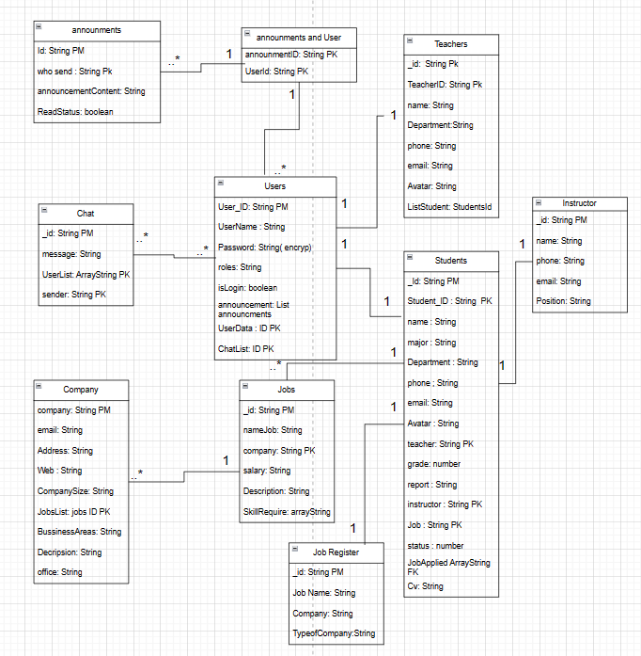

Figure 43 database diagram

In the database system, there will be seven main entities: Users, Teachers, Students, Job, Company, Chat, announcements, and some secondary entities such as instructor, Job Register, announcements, and User.

Among these entities, the main entity capable of linking all data is Users. Users have the function of storing security-sensitive information and determining the user's role in the system. There is a one-to-one relationship with entities such as Teacher and Student to point user data to these entities to ensure there is no duplication of user data with each other.

Teacher and Student are two entities created for the purpose of storing user details about name, work image, etc., so these are considered User Data to help queries become clearer.

Because the website has functions related to job search, Students will have a relationship with the Job entity to store jobs that students have applied for. In addition, the Student entity also has relationships 1- 1 with the sub-entities instructor and job registration because these entities are used to store student registration information in the database.

The Job and Company entities are used to store information and have a one-to-many relationship, because in reality, a company has many jobs to do.

Chat and announcements will assist in creating additional functions for the system website, so there will be a relationship with each User.

# CHAPTER 4

# IMPLEMENT AND RESULTS



## Implement



### Front End

#### Initialization

To initiate a UI project the project uses some of the technologies already mentioned to assist in the process of building and developing the UI part.

First of all, use Vite to assist in quickly building and initializing a project using commands:

* npm create vite@latest

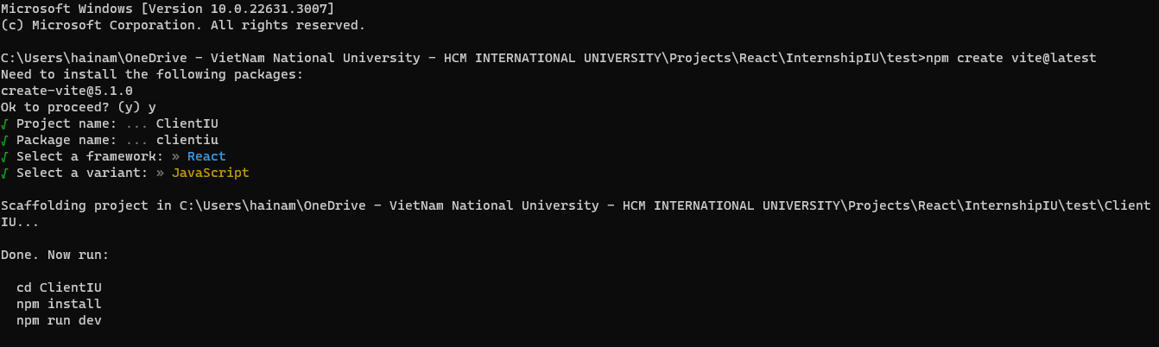

Figure 44 vite init

Through a few simple setup steps to have a project using react and using the javascript language for development.

Use commands:

* npm install :Install dependencies and libraries for the Project
* npm run dev: This command will Run Vite's developer mode, which automatically launches every time you back up, making code development easier.
* npm install @mui/material @emotion/react @emotion/styled : Load MUI archive support to build component interfaces.
* npm install axios: install library axios to get data from the API Server
* npm redux: install redux library

#### Folder Structure

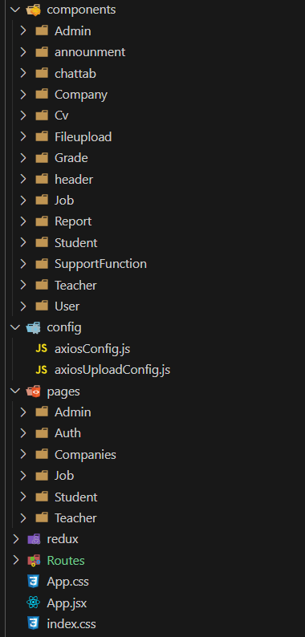

Figure 45 Folder structure of Front End

The directory structure is very important for project maintainability and scalability. It helps developers easily locate files, manage dependencies, and understand the project's architecture, making it easier to read and understand the project's code.

In this project, we have several main directory pages, routers, redux, Components, config, and app.jsx that act as headers to render components in the project.

Pages are the folders to save compilations to create a complete page for rendering, for example, pages for students and pages for teachers.

redux folder to contain pre-made actions that support the use of redux in code.

Routes folder: contains code used to distribute pages so they can be broadcast to the browser.

config folder contains setup files for some required libraries.

components: contains necessary components for the website that can be reused anywhere in the system.

#### Set up Redux

Connect Redux to reacts:

* Wrap your App component with the Provider from react-redux and pass the store as a prop.

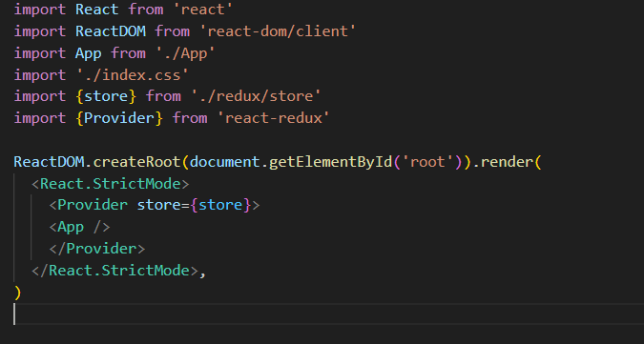

Figure 46 redux setup in main.js

* Create redux action and store to handle state in react.

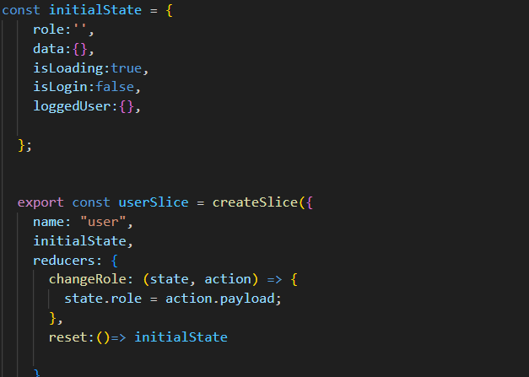

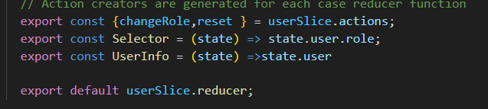

Figure 47 userSlice and initial State set up.

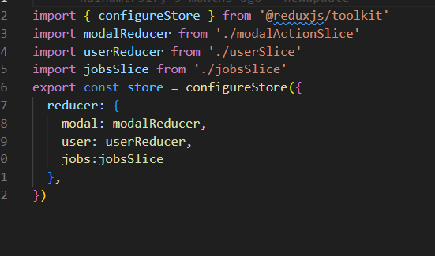Final after set up can use redux by use useDispatch and userSelector to run action or get state form redux store.

Figure : File Store for redux Set up.

#### Set up Axios

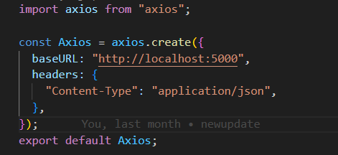

Figure 49 Axios config

Create an Axios config file in the config folder and set baseURl as the path to the project server.

After creating the config file, the web project can freely make API requests to GET, POST, and PUT to the server.

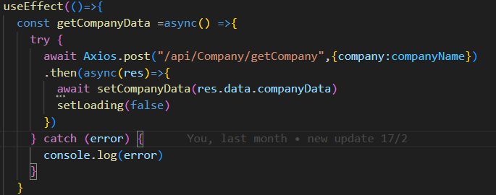

Figure 50 Run Axios to get data.

#### Set up Route in React

Use the react-router-Dom library to create routes for the website.

The router tag will wrap routes and routes that have the ability to allocate different name addresses to run the generated components.

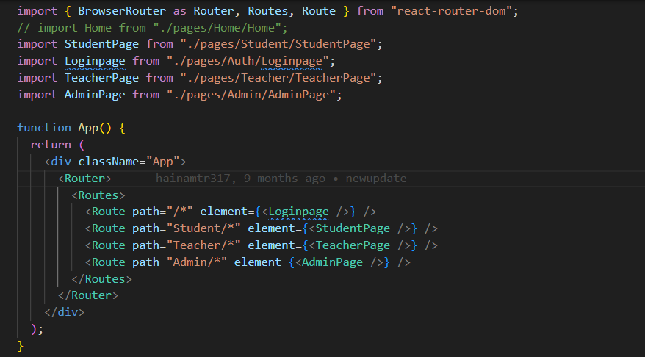

Figure 51 Set up react-router-Dom.

Once setup, a set of URLs will be created for the sample website http://localhost:3000/ which will display the login page. http://localhost:3000/Student will display the page for students. http ://localhost:3000 /The teacher renders the student's page

### Back End

The server part will use the express framework to build an API server that connects to the database and saves information there to be able to execute different queries. At the same time, use jwt token to create the login process. The database part will use MongoDB as NoSql for scalability and powerful querying capabilities.

#### Init

Run comman npm init to create new nodejs Project

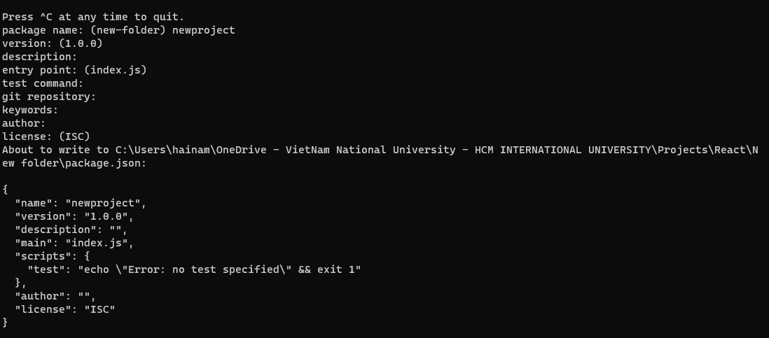

Figure 52 Init new Backend project

Create a file index.js it file to run applications of the entire server system.

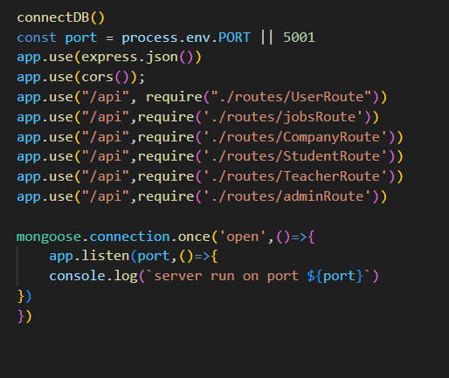

Figure 53 code to run server in port 5000

Run npm install Express mongoose jsonwebtoken nodemon cors.

Download the necessary libraries for system initialization and development. nodemon is a library that works similarly to dev mode to help speed up the application development process.

#### Folder Structure

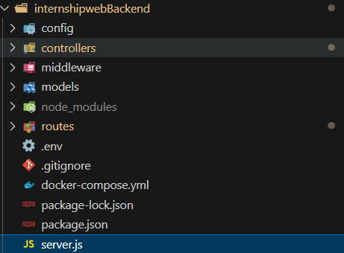

Figure 54 Folder Structure of Backend

The configuration includes different folders and is compatible with the folders in them.

Config: Config folder will store MongoDB's config file, and a number of other service applications that need config.

Models: is the place to store all Schema used for interacting with the database. For example, some schemas user Schema, Teacher Schema, etc.

Routers: The route directory is used to store split files and create paths for the REST API server.

Controllers: Is the place to store functions for each object such as Functions for students and teachers. These functions are mostly functioning that link with the database to issue queries and return data to the user.

#### Set up mongodb

Using docker to run MongoDB helps ensure the consistency of the application's build environment and runtime environment, thereby ensuring the stability and connectivity of future applications.

First, to set up MongoDB on docker in this project,

we will create a docker-compose.yml file to define and run multi-container Docker applications.

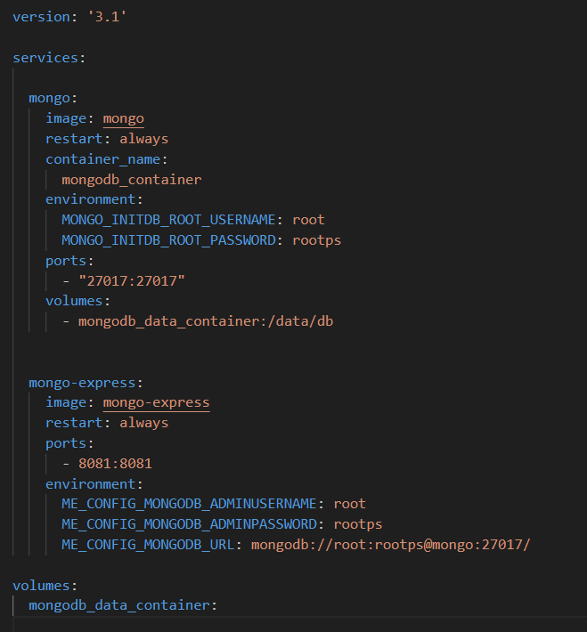

Figure 55 Docker set up for MongoDB.

Here we create 2 services that will run first: mongo is used to create and run MongoDB and this service will run on port 27017 the default port of MongoDB.

The second service is mongo-express, which supports database management and will run on port 8081.

Run command line docker-compose up –build for docker get file and build follow config.

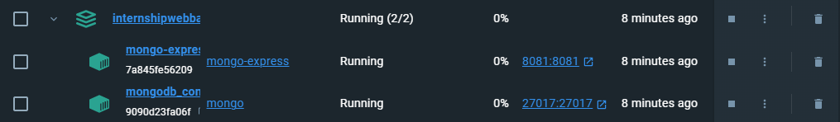

Figure 56 container run on docker.

After completing the construction. You can log in to http://localhost:8081/db/test/ to manage data in the database.

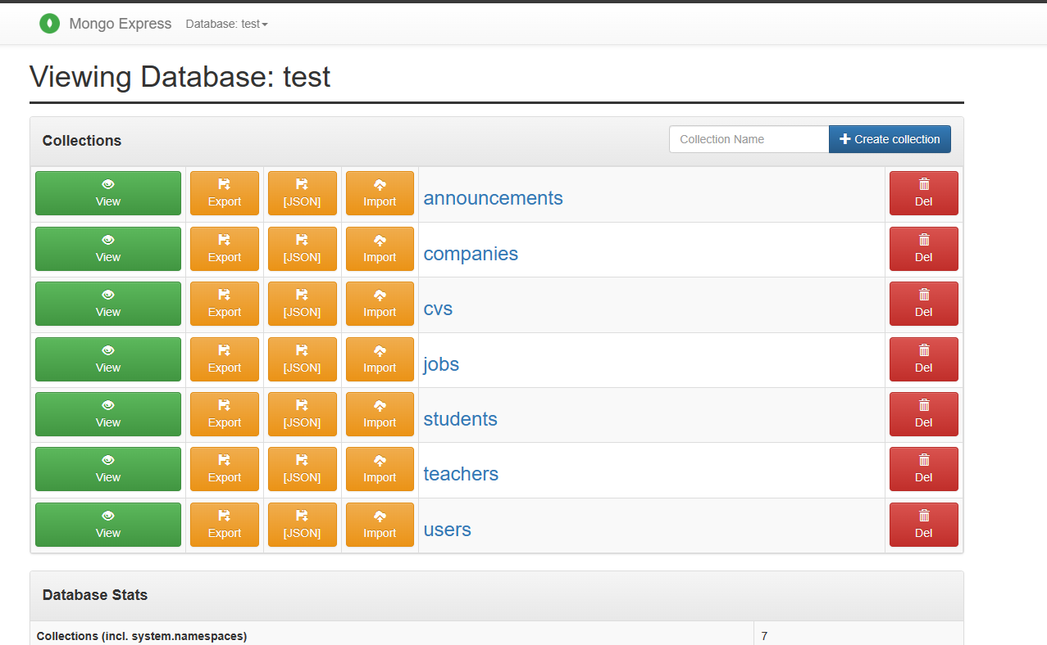

Figure 57 Manager database MongoDB

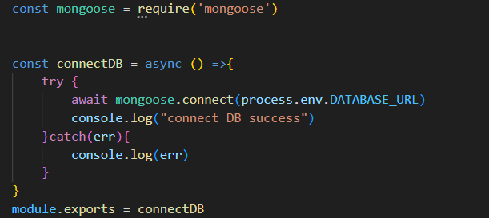Use the mongoose library to create config files and connect to MongoDB. Once completed, the project can connect to the database and execute queries that the user requests.

Figure 58 set up connect MongoDB.

## Results



### Sign In Page

A page on users is the authentication page here is a page for students or Teachers and Admin will use their account provided by the school to access Internship IU. Based on the account's role, the website system will redirect users to the correct page.

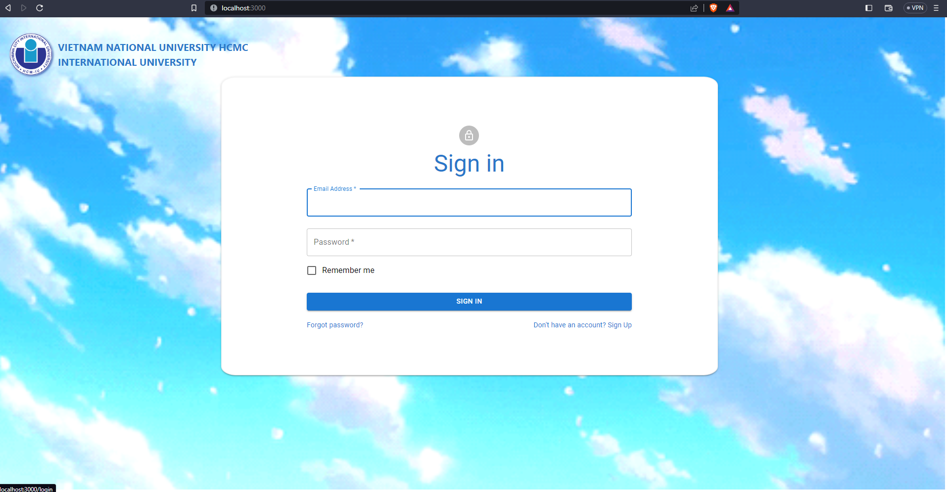

Figure 59: login page

### Student pages

#### User information pages

This information of the student page will display all critical information about students and show the processed internship of students.

The student's internship process will have 5 statuses: application, job registration, internship, thesis writing, final grading, and the end of the internship. The application status is the initial state, only when the student registers the job information as well as the instructor information for the teacher, it will switch to the second state. After being confirmed by the teacher, it will switch to internship status. The fourth state of writing the report will automatically change when the date the school requires the report and go to the last state when the student submits the report.

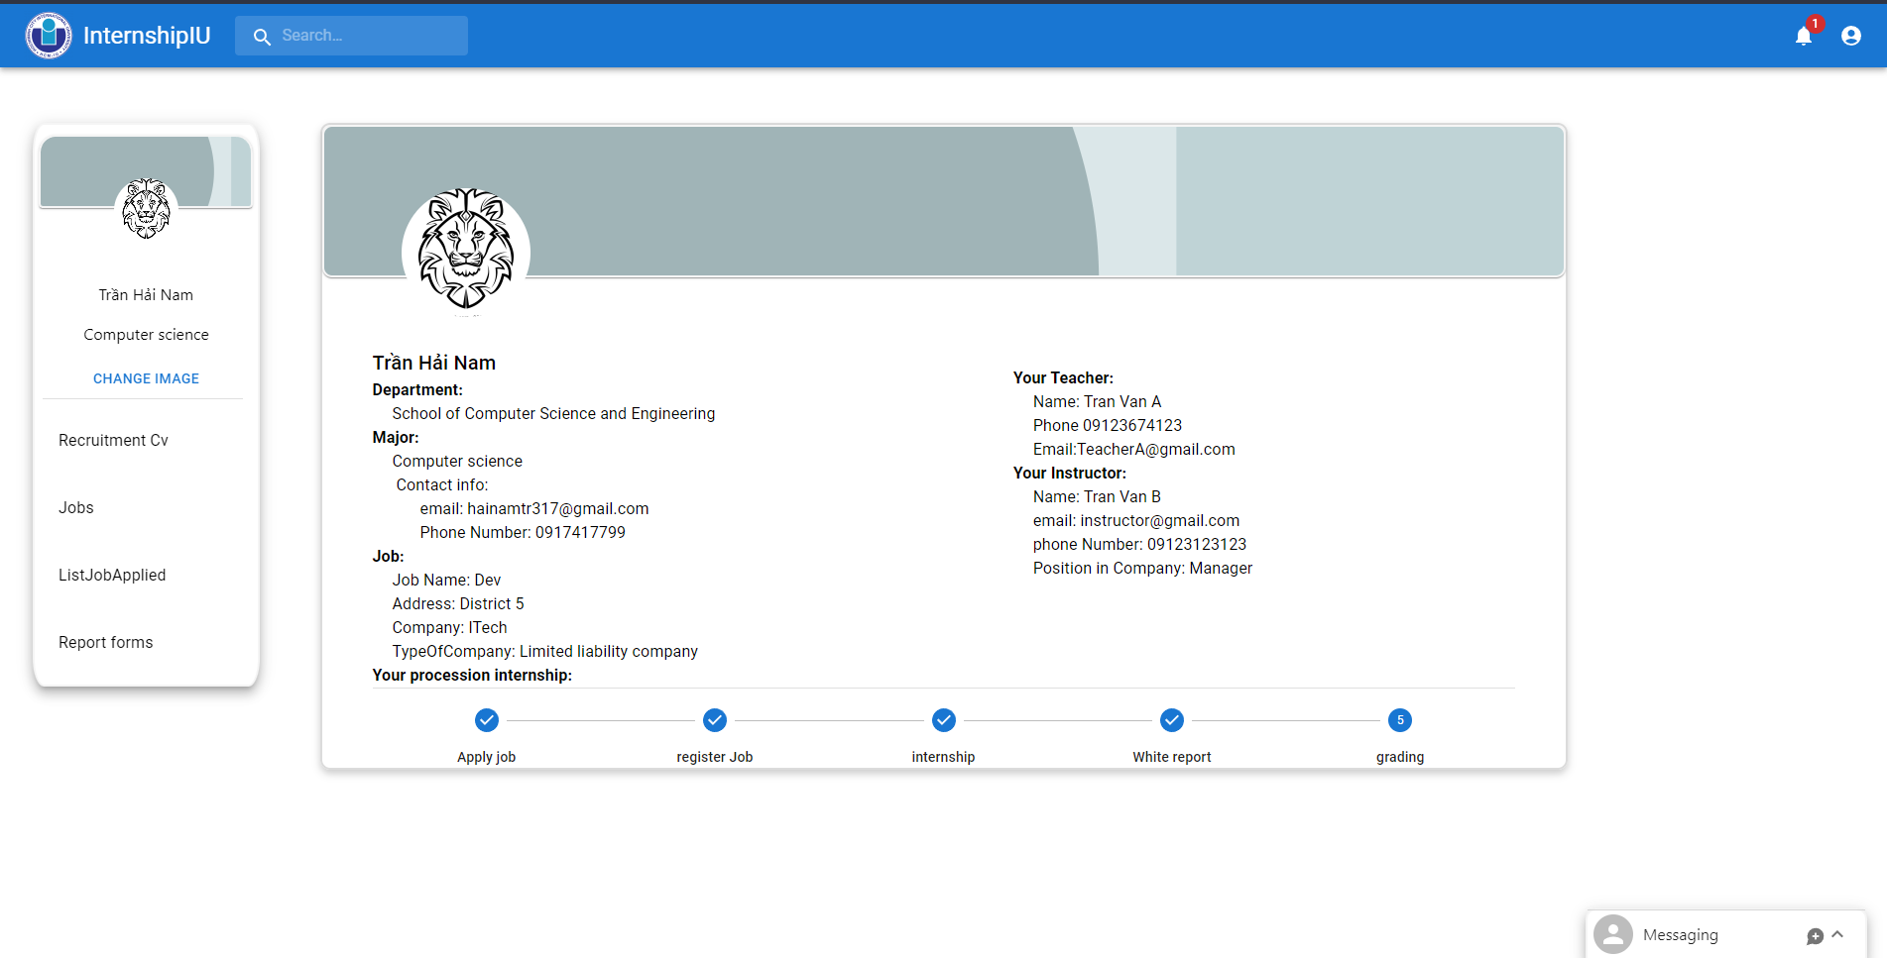

Figure 60: User information page

#### Find Job and Home Page of Student role

Next is the home page of the student role. On this page display list of jobs for students applying. Jobs will display based on Students area of expertise.

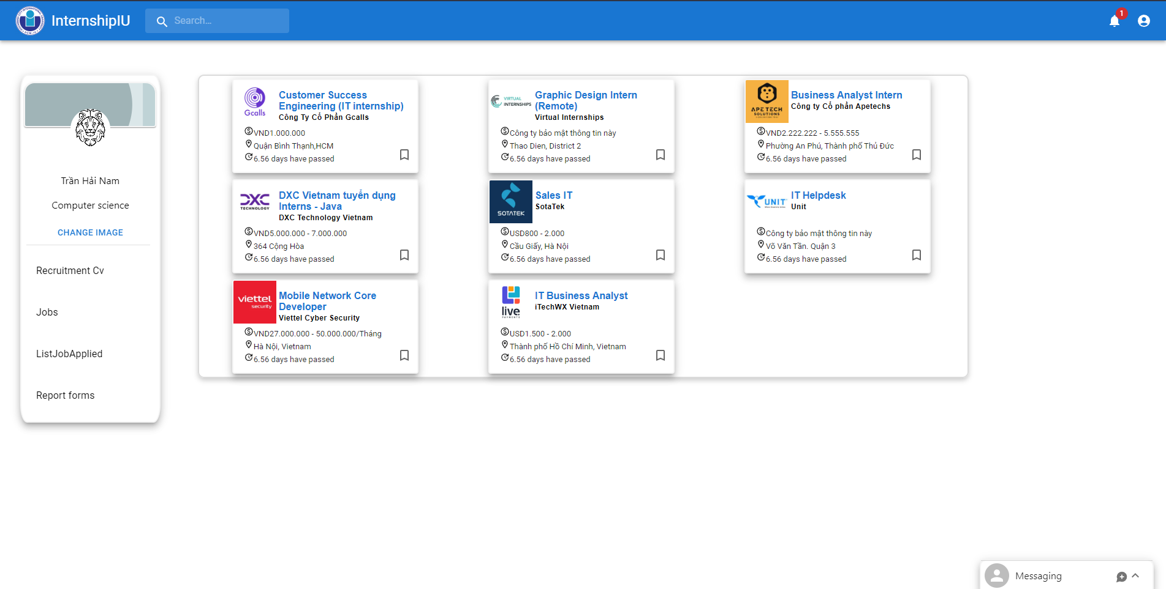

Figure 61: Home page of students

This modal display details of jobs for students can read and apply for jobs. Modal job will display name, company name, requirement, description, …

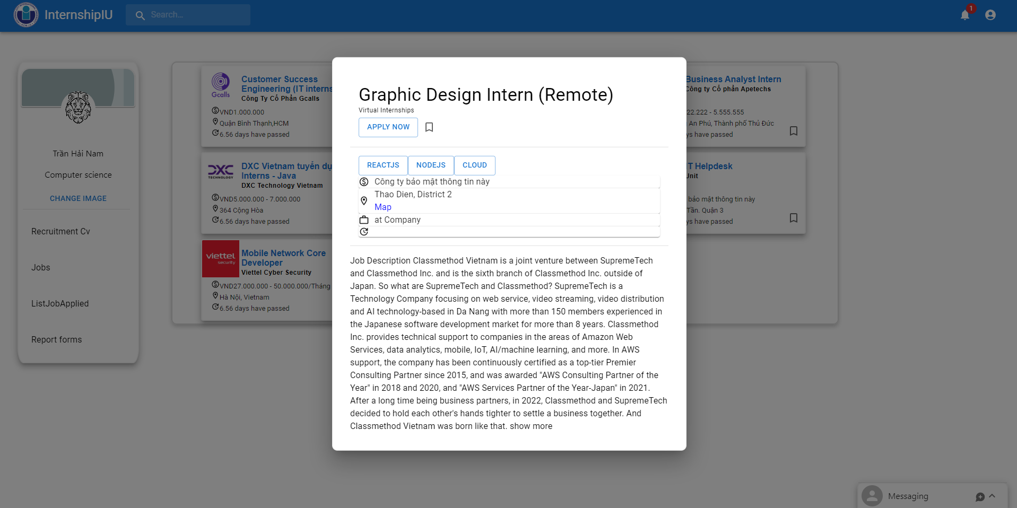

Figure 62: Modal of job view

When user click title of job in modal job it will redirect to company page.

#### Job page

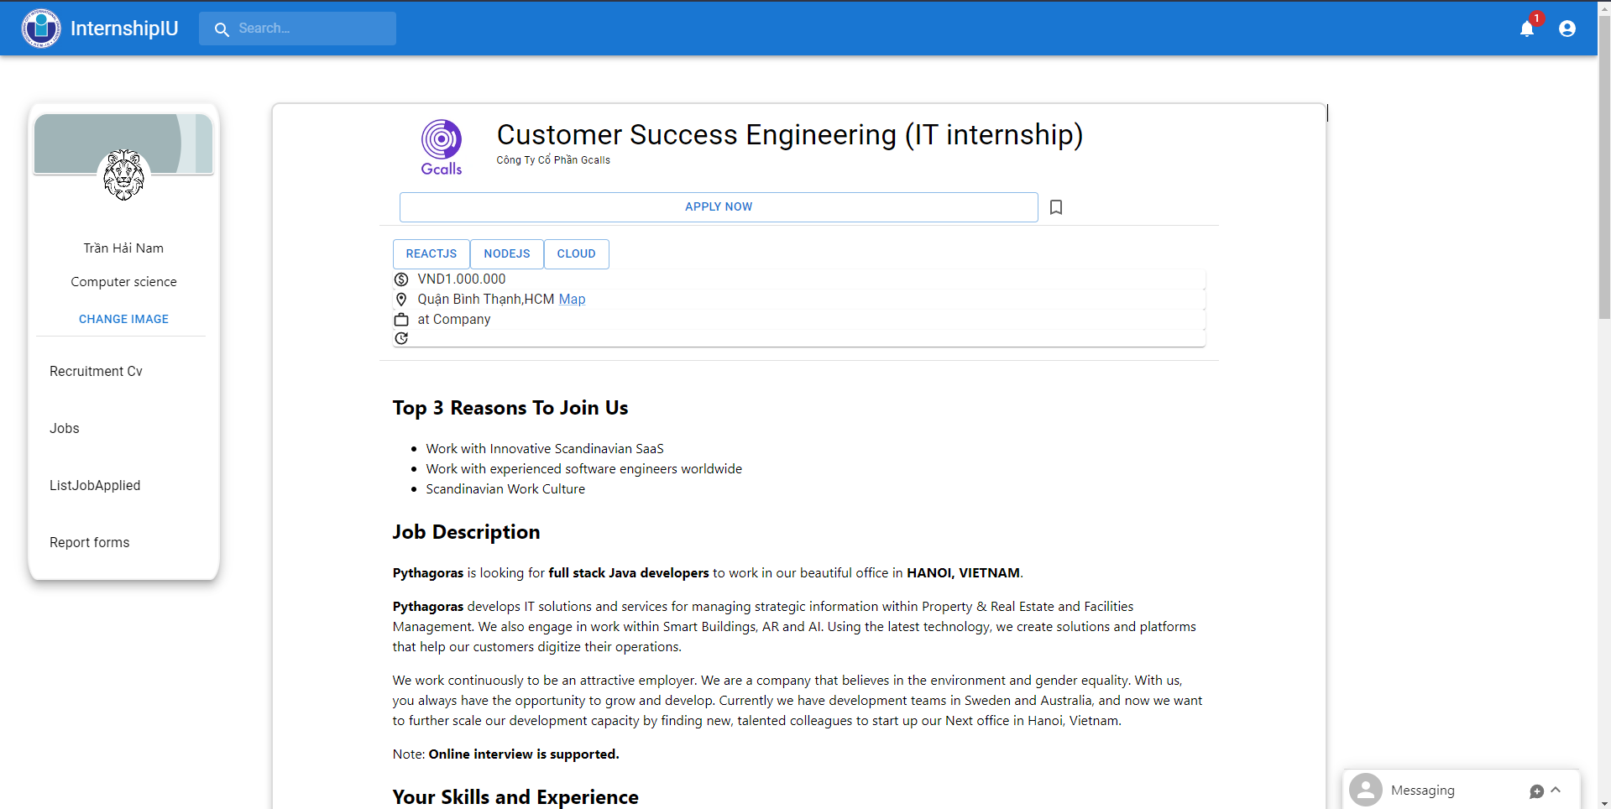

Figure 63: Jobs page

#### Company Page

The website also has a company page for students to view more information about that company and understand what company they apply to.

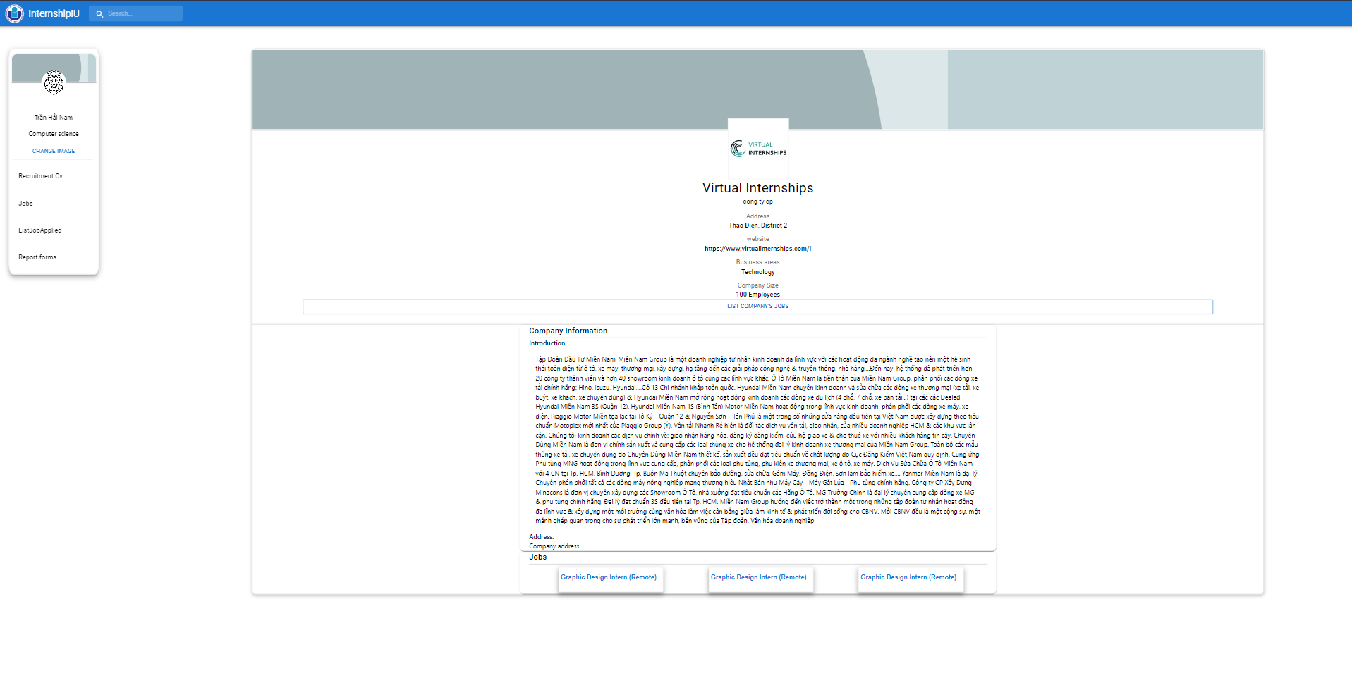

Figure 64: company page

#### Apply page:

The application form page will display job and student information will send to the recruiter by mail.

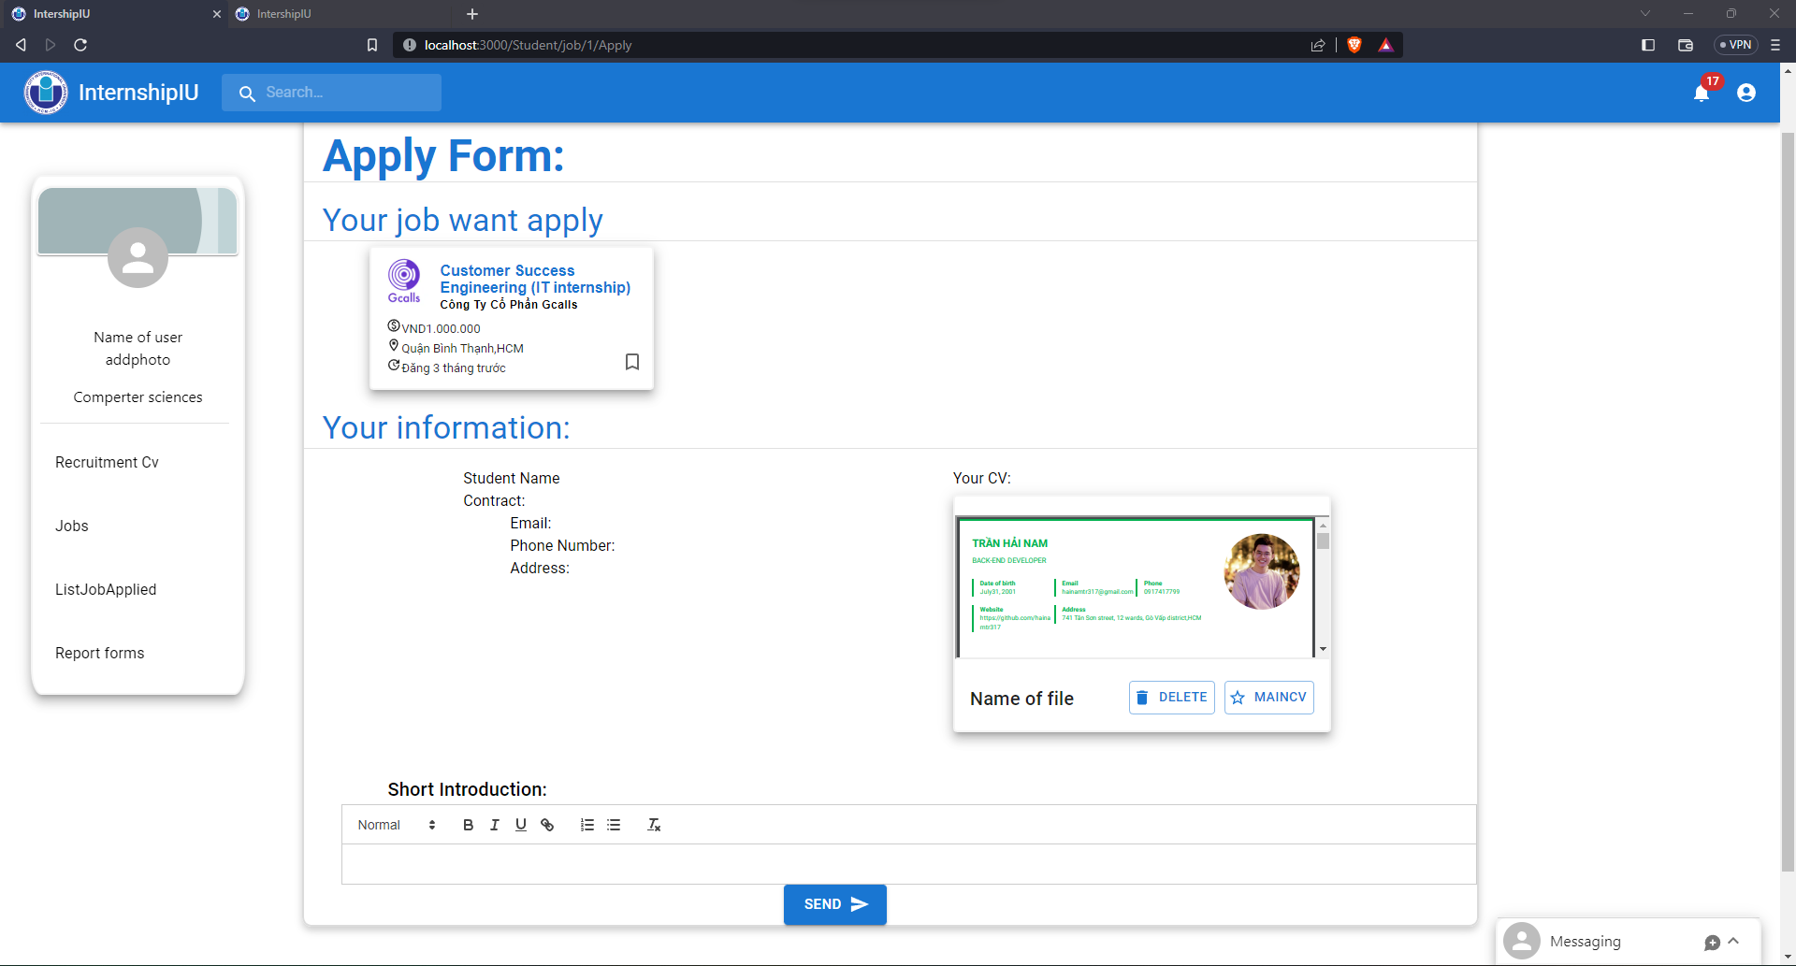

Figure 65: Apply form.

#### Job Applied Page

The jobs applied for will be displayed on the applied page. On this page, students can register their job if they can find a job outside, or student receive a job from the Company they apply to.

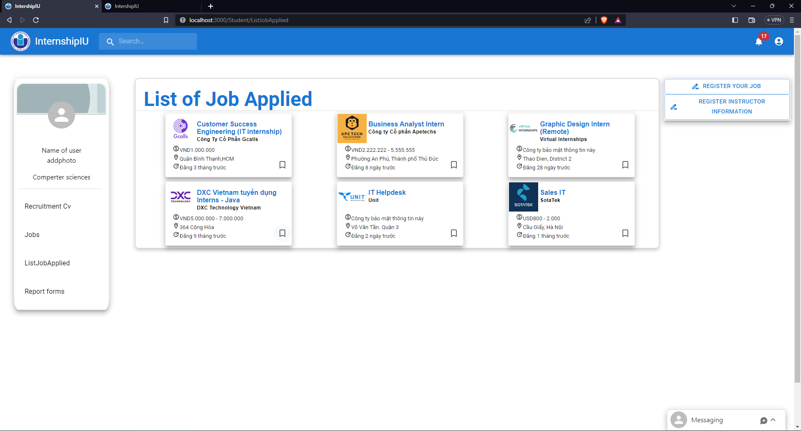

Figure 66: Display jobs applied page.

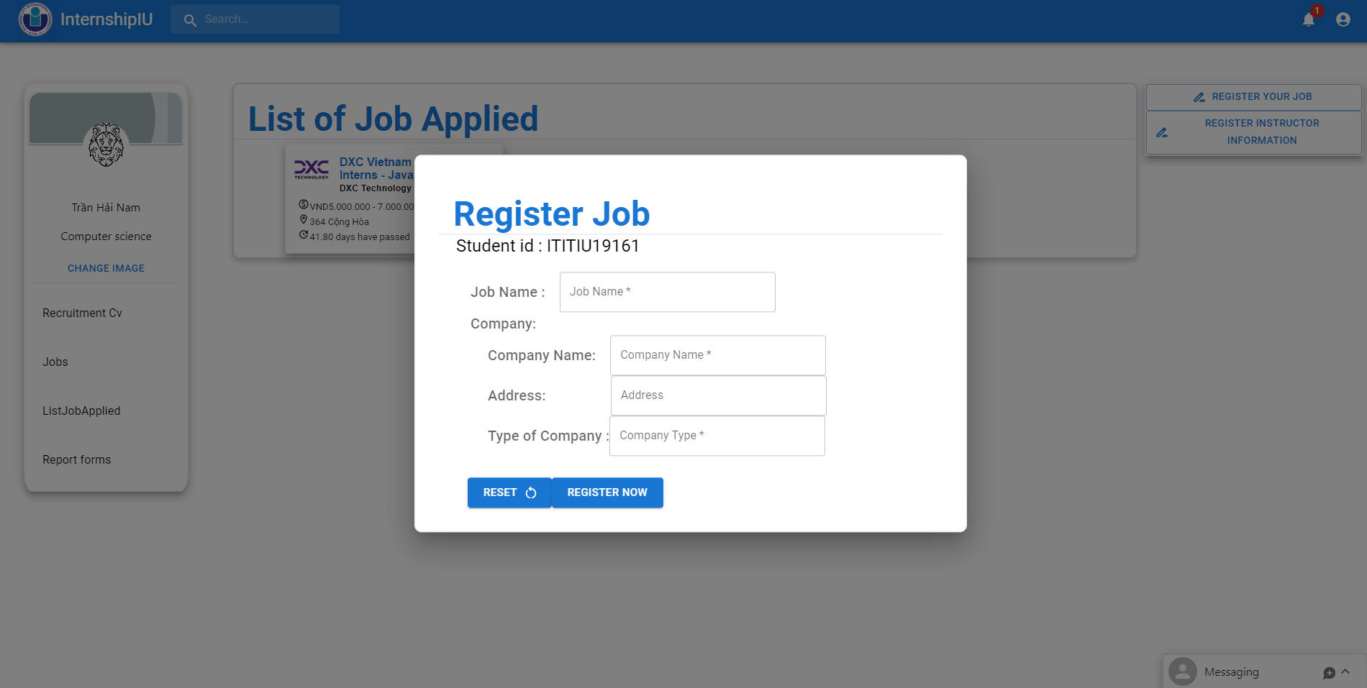

Figure 67: Register job form

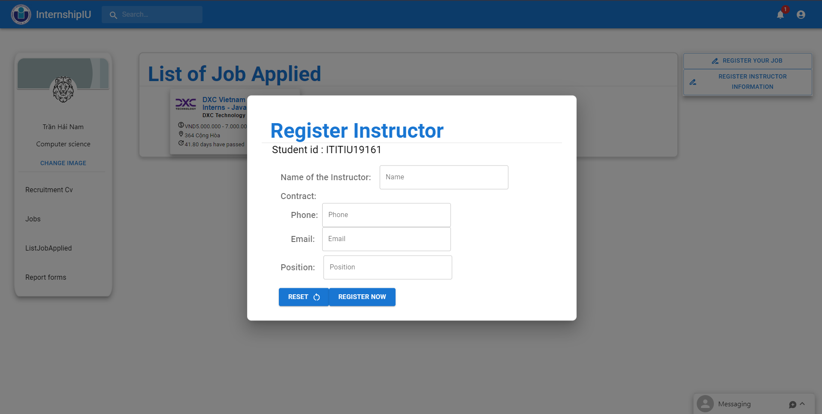

Figure 68: Register instructor form

#### Report Page

After finishing the internship, they can find a report form on this website and submit it through the Internship IU website.

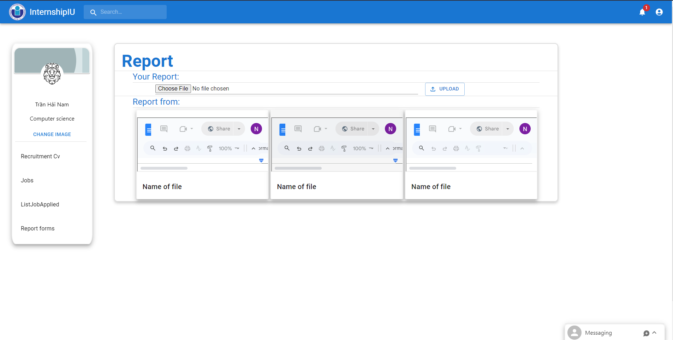

Figure 69: Report page



### Teacher Page

#### View Students Page:

Teachers will see a list of students and their managers. On this page, Teach can quickly observe the process of student support immediately.

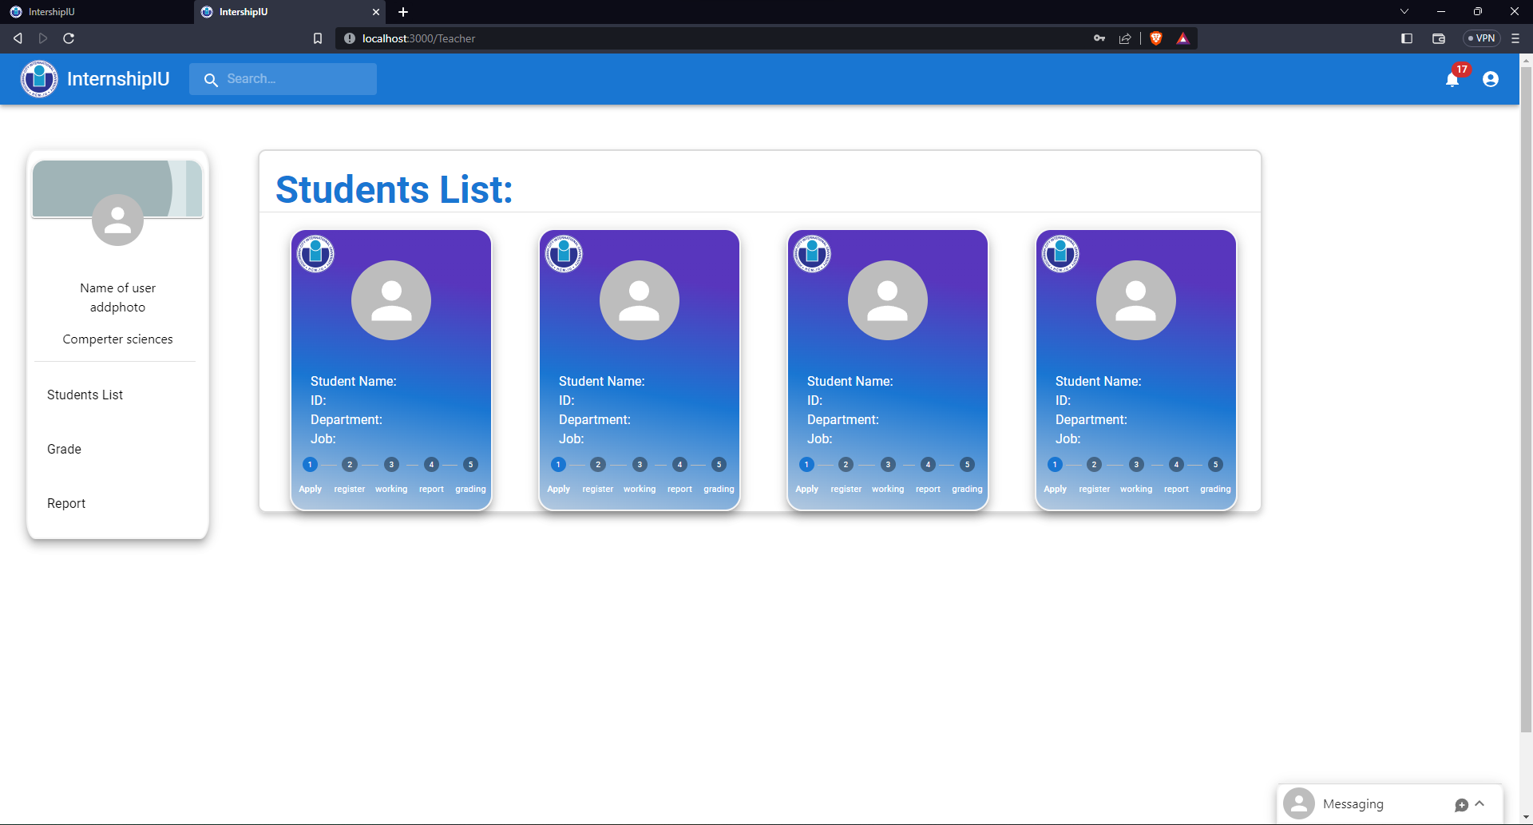

Figure 70: Home page of Teacher

#### Student Page information

When clicking on the student card. The web will redirect to the student page to view detail. On this student page, the teacher can grade and make an announcement if students have problems with their CVs or report.

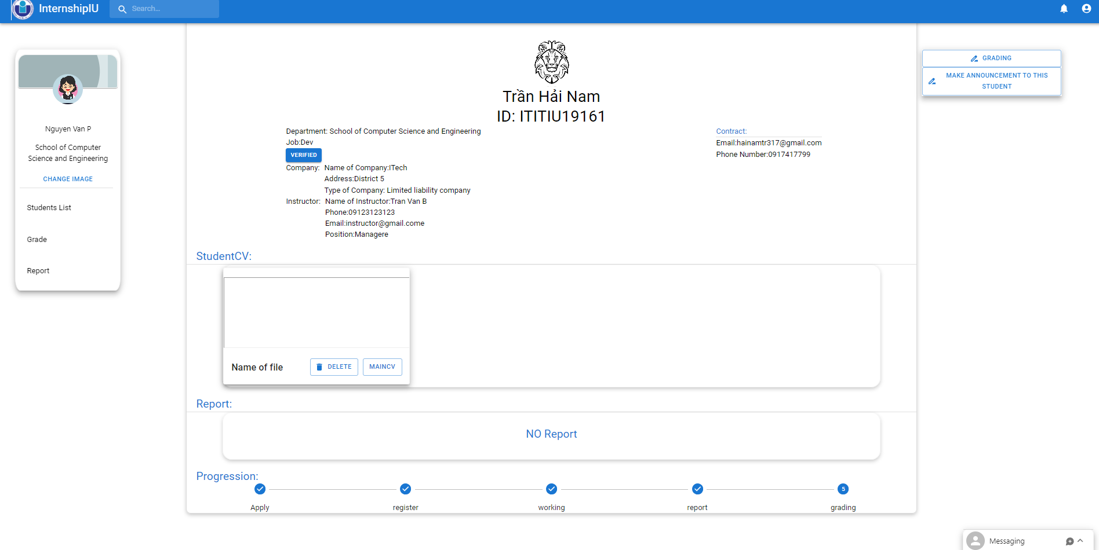

Figure 71: View Student

Announcement form:

Support teachers to send notifications to students about important issues.

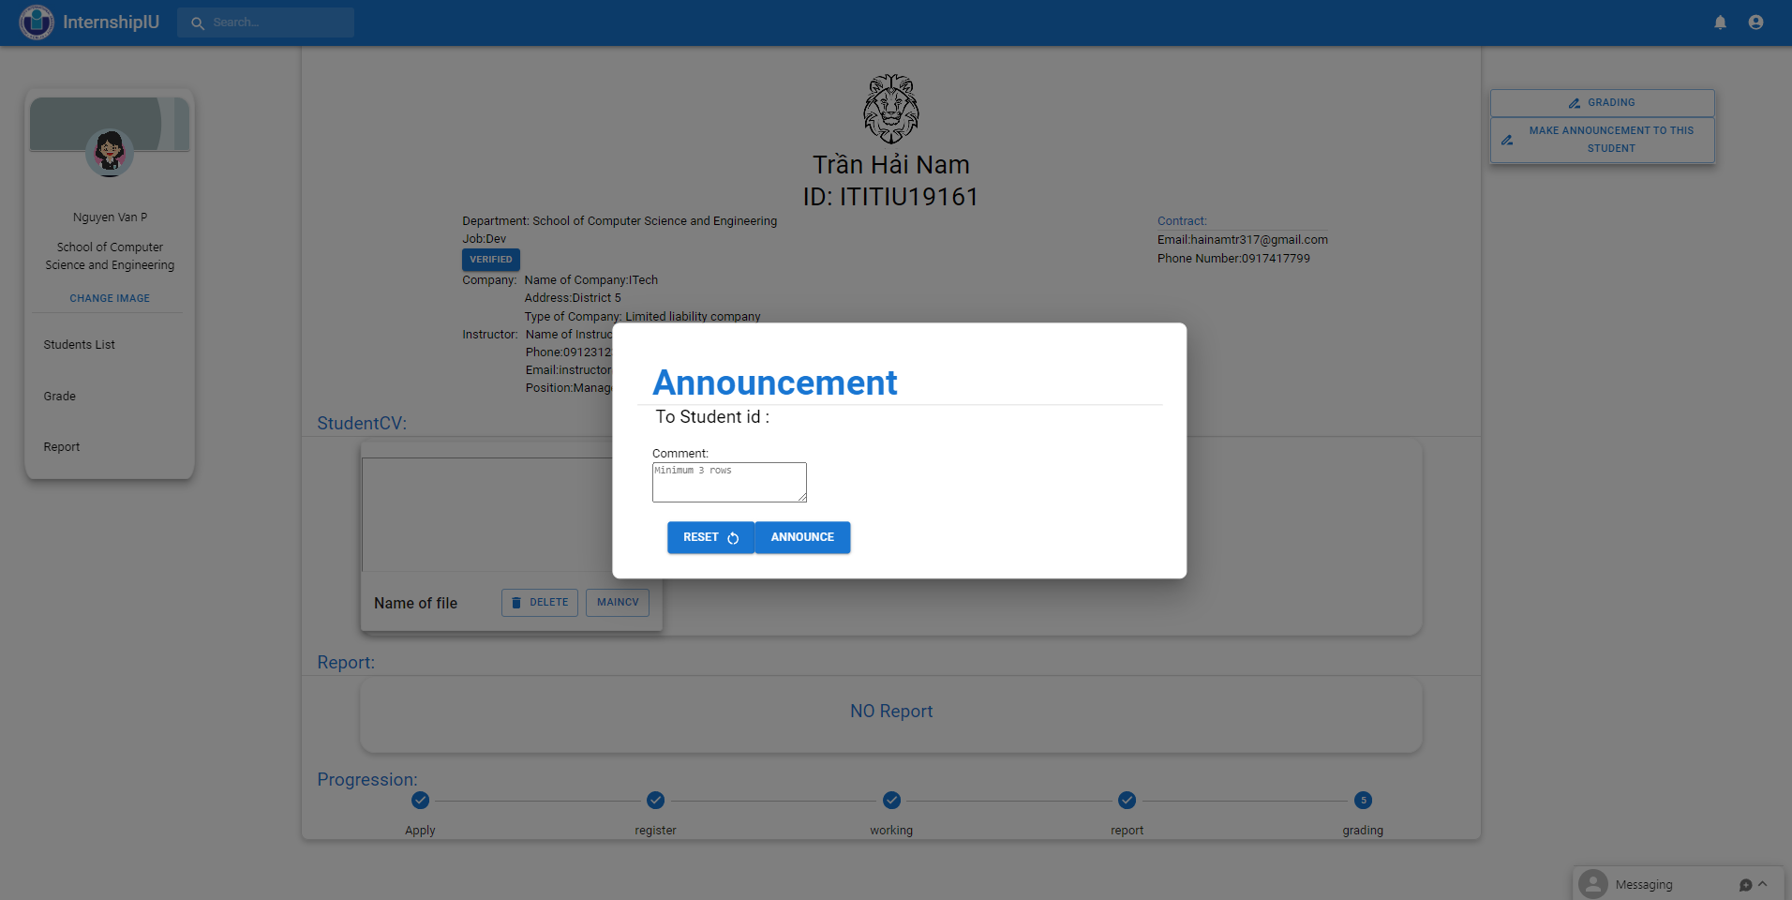

Figure 72: Announcement form

Grade form

Teachers can rely on the information viewed in the student information page and give the most reasonable and fair score.

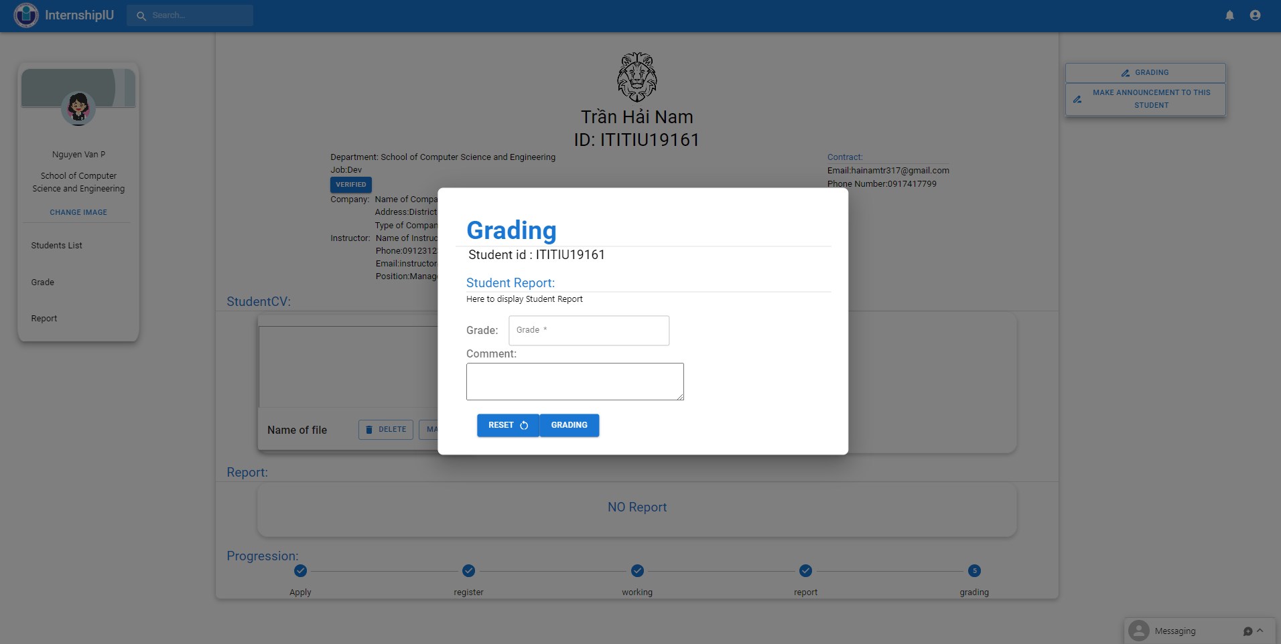

Figure 73: Grading form

#### Grade Page

This grade page will display a list of students with their grades, easy for the teacher to observe and modify if the Teacher has a problem. It also can export a Excel file for teacher can make a report for school later.

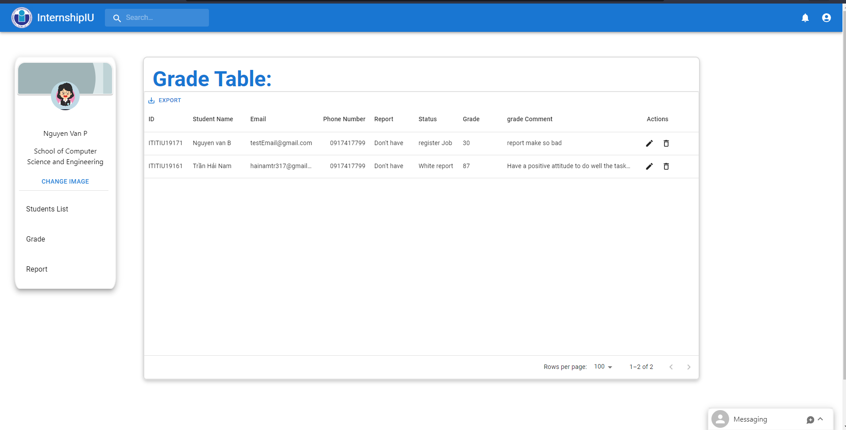

Figure 74: Grade view page

#### Report Page

Teachers can find some report forms on this page and submit them to the school by mail.

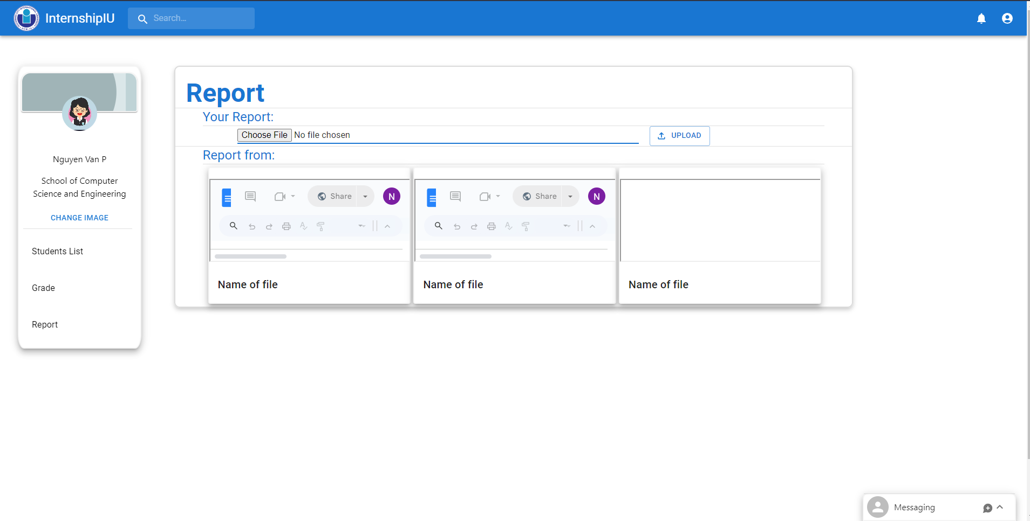

Figure 75: Report page

### Admin

The admin page will give the admin all the rights to view and modify information for users such as accounts, roles, companies, and even jobs.

Admin will manage 3 main objectives on website are User, Company, and Jobs. Admin's main activity is to add jobs and companies.

#### User Manager Page

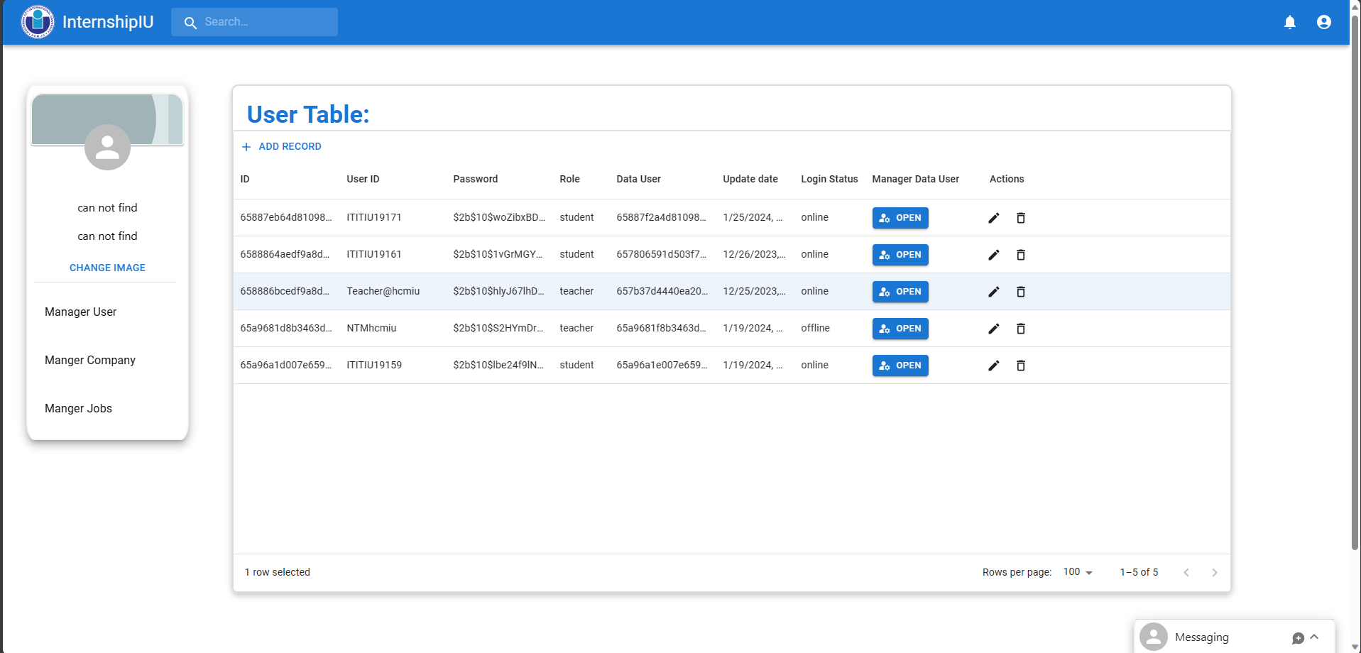

Figure 76: Manager User

Administrators can create new teachers and students according to the form.

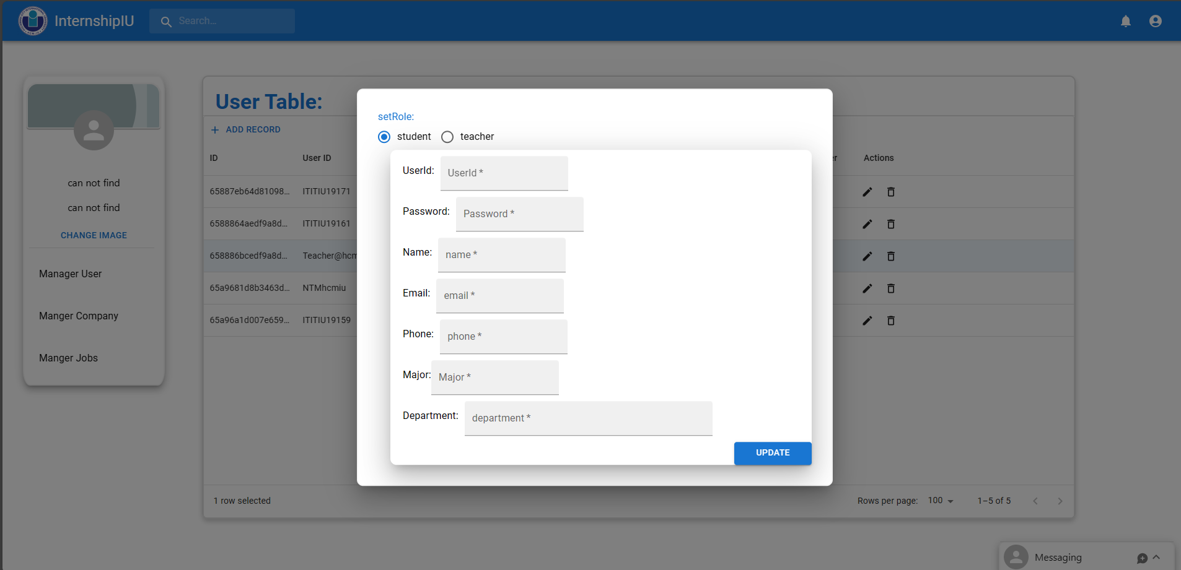

Figure 77 Create student form.

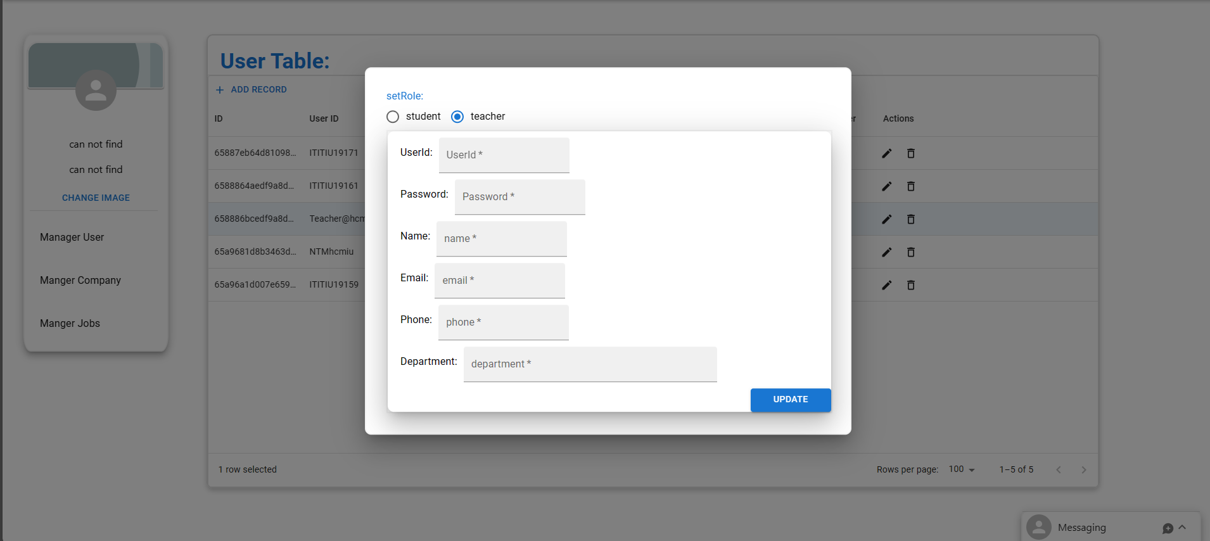

Figure 78 Create Teacher form.

#### Company Manager Page

The page is only accessible by administrators to manage and modify the companies' content.

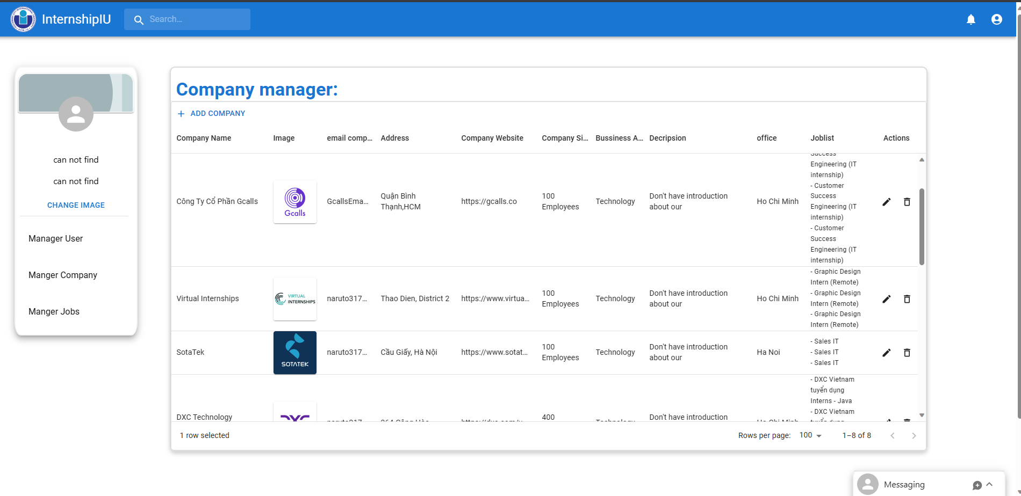

Figure 79: Manager companies

Create a new company directory according to the available template

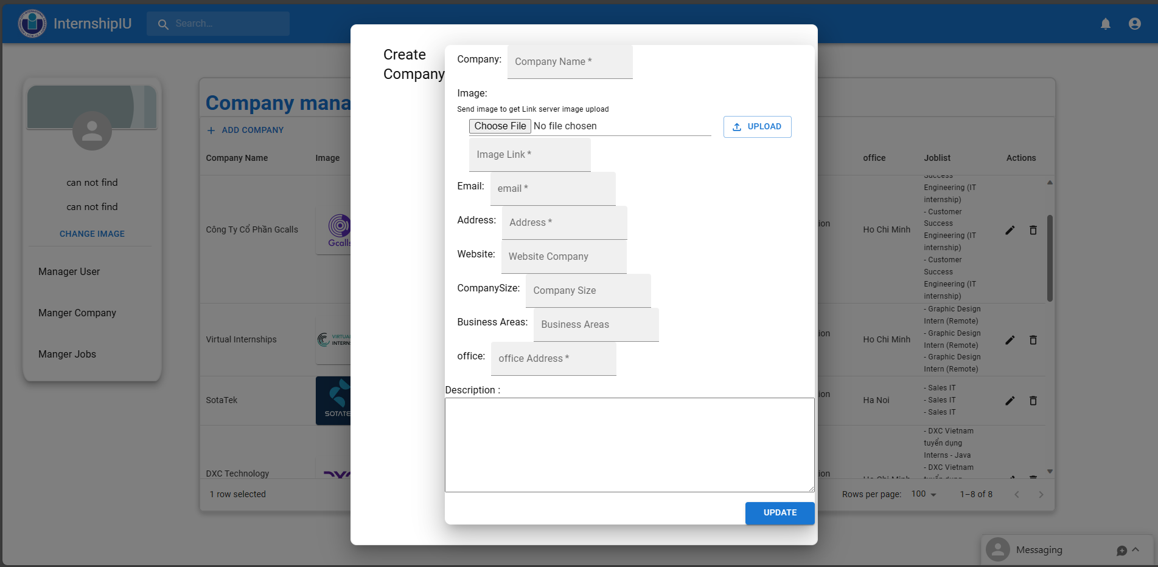

Figure 80 Create Company form.

#### Job Manager Page

The page can only be logged in by the administrator to manage all data related to the Job.

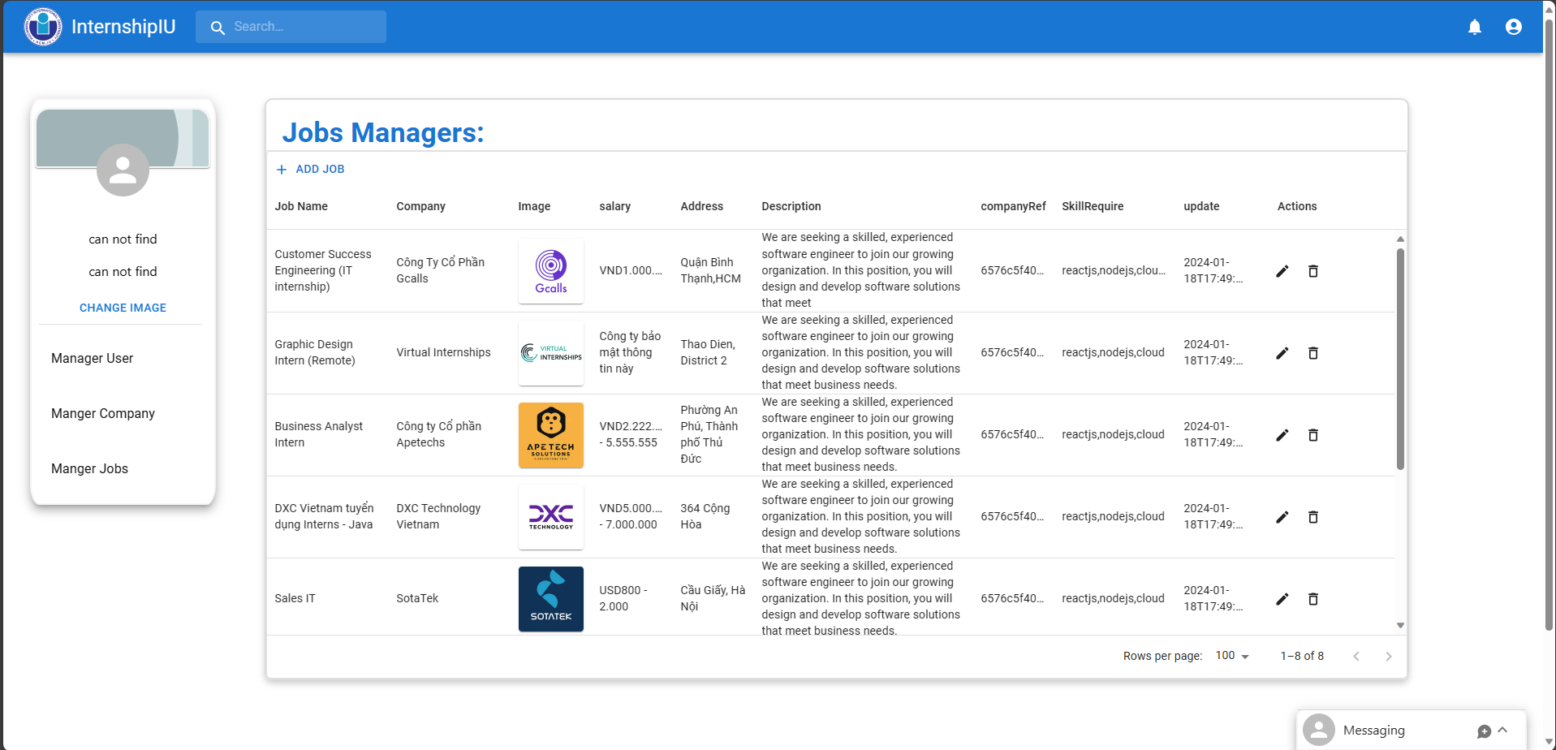

Figure 81: Manager Jobs

Create new job based on form.

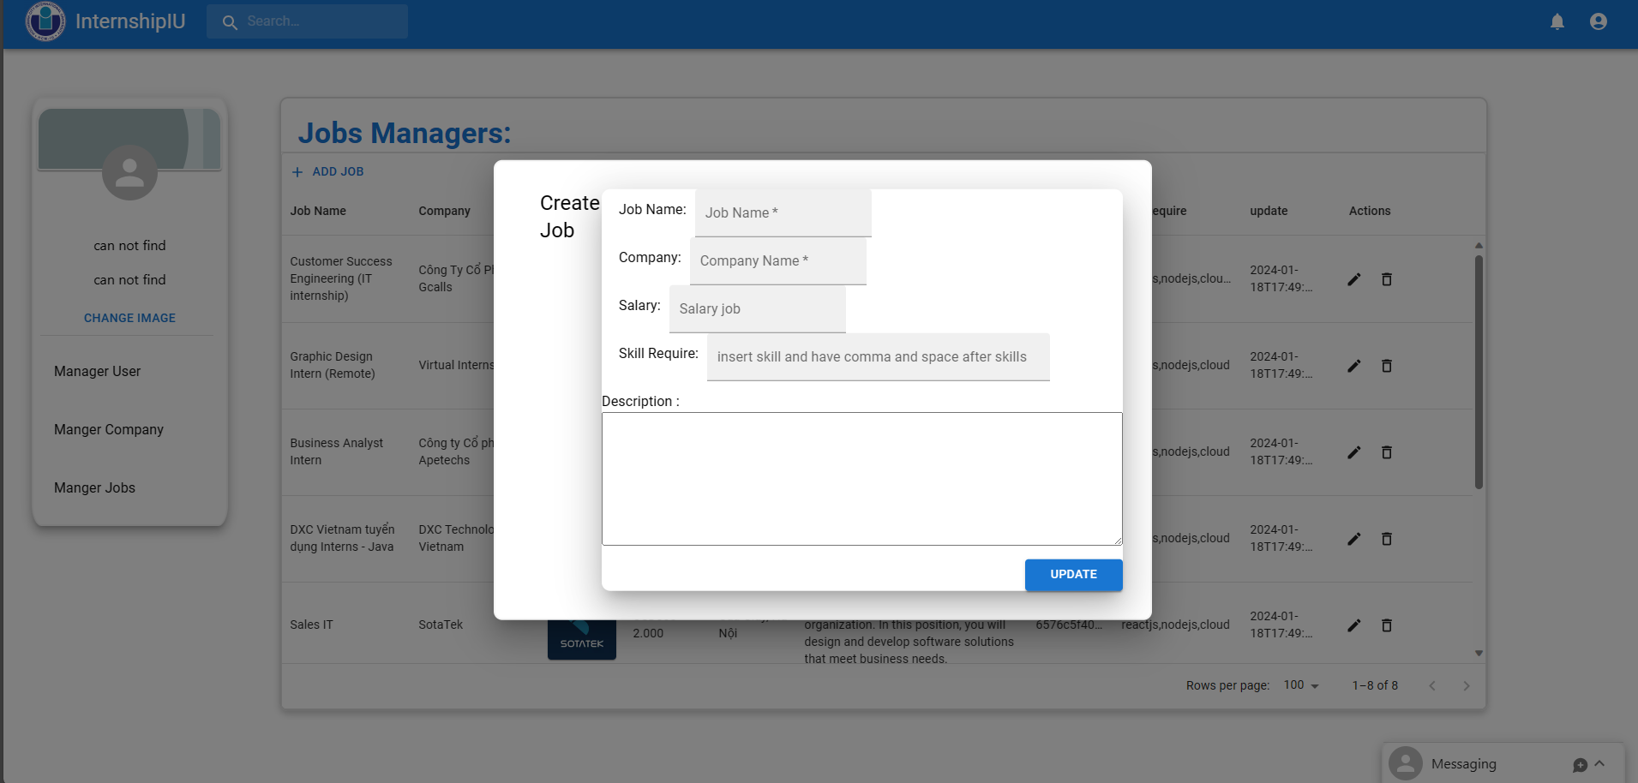

Figure 82 Create Job form.

# CHAPTER 5

# DISCUSSION AND EVALUATION



## Discussion

The proposed project centered on the establishment of a dedicated website to simplify and enhance the internship assistance system for students and professors at the international university. The major purpose of the project is to establish a platform that fosters better communication, streamlines administrative operations, and improves the overall internship experience for instructor and student users.

**key target**:

- User-centered approach: This site strives to emphasize the requirements of two key user groups: students seeking internship opportunities and professors administering internship programs.

A user-friendly design and clear navigation routes will be built to enable accessibility for all users.

- Effective internship management: The website will offer a centralized area for students to apply, monitor internship progress, and get feedback.

Teachers will have tools for seamless administration, enabling them to assess applications, grade internships, and keep clear contact with students.

- Advanced communication channels: The website will combine tools to enhance communication between students and professors throughout the internship process.

Real-time alerts, messaging systems and bulletin boards will be installed to boost cooperation.

- Send CV and feedback: Students will be able to submit their CV directly to the site, offering ease for both students and professors.

Teachers may give helpful input on CVs, helping students enhance their job profiles.

**Expected benefits:**

- Reasonable process: The project seeks to simplify and automate many activities associated with internships, minimizing manual efforts for both students and professors.

By centralizing information and procedures, the site attempts to promote a more efficient workflow.

- Improve openness: The platform will promote transparency in the internship application and grading process, ensuring that all stakeholders have a clear grasp of progress and results.

- Make choices based on data: Robust reporting options allow instructors to produce reports on internship success, allowing for data-driven decisions and program enhancements.

**Challenges and mitigations**:

- User training:

Full training and support materials will be provided to ensure that both students and teachers can navigate and use the website effectively leading to enhanced performance during the internship. - Data security and privacy: Strong security measures will be implemented to protect sensitive information, including student CVs and grading data.

The University Internship Support website is set to be a transformational tool for the worldwide university community. By concentrating on the requirements of students and instructors throughout the internship process, better management, and enhanced communication, the project intends to optimize the administrative process of the internship process and boost involvement. connection between teachers and students. Through coordinated efforts, we anticipate establishing a platform that will contribute greatly to the success and expansion of our internship programs.

## Evaluation

Overall assessment of what the project has accomplished in terms of interface, functionality, and applicability to solve difficulties for specific users. These are the two main audiences of the teacher and student platform. tablets.

**Some highlights**

* The interface of the web system is designed to be simple, neat, and intuitive so that users can clearly understand the functions of the website and use it comfortably.
* Internship process system for students. Distributing the internship process, students can easily check their progress.
* Reduces third-party tasks and software for teachers. makes it easier to observe and manage students while also helping teachers give transparent assessments and scores because the assessments are based on actual data.
* The management page for the operator is designed to be simple and easy to operate, suitable for everyone, allowing people who do not need to be too tech-savvy to operate and manage.

**Application Limitations**

* For data entry processes that lack support functions for large amounts of data, for example, inputting 100 different data into the system at the same time is still not possible.
* The teacher's process has not been optimized due to mandatory actions on the school's part.

# CHAPTER 6

# CONCLUSION AND FUTURE WORK



## Conclusion

The completion of this project marks an important step forward in the development and evaluation of the Web Support System for the internship process at the national university. With the support and close cooperation with my advisor, Ms. Tu, the Project has achieved certain goals in the process of improving the internship subject at school, focusing on user-friendly design. effectively navigate internships and positively impact students and administrators. This project has proven its effectiveness in improving internship management in the digital age.

By prioritizing user-centered design, the UI is not only easy to use but also provides an intuitive experience for students, teachers, and administrators alike. Adding an internship tracking function to track internship issues is a valuable improvement, supporting proper internship management and providing students and teachers with detailed information. details about the internship process at school.

Working on this project was a transformative learning experience, cultivating programming skills, research, and self-discipline. Acting as an engaging workshop, it raised the level of development on specialized issues like building front-end using JavaScript, React and MUI building backend with Nodejs and express. Self-directed learning cultivates adaptability and precise thinking in an ever-evolving technological landscape. The project requires sustained focus, involving complex details of rule implementation and strategic decision making. In addition to technical skills, it also nurtures essential life skills such as effective communication and problem solving, which are valuable lessons for enhancing and developing self-worth.

## Future work

With the development of current digital technology, the website has many disadvantages, so for the project to have a chance to develop and improve, here are some things that need to be developed for the project.

- Adding an app platform to the application, developing additional applications to support and help overcome the disadvantages of the web platform. Helps the application become more popular due to the development and popularity of phones today. Helps make notifications faster and more accurate because notifications on the web may not be read because they are not logged into the website.

- Continue to collect user information and improve the website

- Create a forum website to share information related to internship issues

# References

(DSA), S. C. (2023, 12 22). *Làn sóng cắt giảm nhân sự có khiến sinh viên lao đao?* Retrieved from ueh.edu.vn: https://ueh.edu.vn/cuoc-song-ueh/tin-tuc/lan-song-cat-giam-nhan-su-co-khien-sinh-vien-lao-dao-71212?app=true&app=true

Docker. (2023). *A container is a standard unit of software that packages up code and all its dependencies so the application runs quickly and reliably from one computing environment to another. A Docker container image is a lightweight, standalone, executable package of* . Retrieved from docker : https://www.docker.com/resources/what-container/

Dokcer. (2023). *Docker overview*. Retrieved from docker docs: https://docs.docker.com/get-started/overview/

glints. (2015). *glints*. Retrieved from glints: https://glints.com/vn/about

Hai G. (2020, March 23). *React là gì? Và nó hoạt động như thế nào?* Retrieved from Hostinger: https://www.hostinger.vn/huong-dan/react-la-gi-va-no-hoat-dong-nhu-the-nao

hamiswillee,Cybersharph . (2023, jun 30). *What is JavaScript?* Retrieved from developer.mozilla.org: https://developer.mozilla.org/en-US/docs/Learn/Getting_started_with_the_web/JavaScript_basics#what_is_javascript

Kollegger, E. (2018, May 15). *What is Axios.js and why should I care?* Retrieved from Medium: https://medium.com/@MinimalGhost/what-is-axios-js-and-why-should-i-care-7eb72b111dc0

Kononenko, K. (2017, November 3). *Going out to eat and understanding the basics of Express.js*. Retrieved from freecodecamp: https://www.freecodecamp.org/news/going-out-to-eat-and-understanding-the-basics-of-express-js-f034a029fb66

layoffs.fyi. (2023). *layoffs.fyi*. Retrieved from layoffs.fyi: https://layoffs.fyi/

LEADERONOMICS. (2022, 7 1). *5 Pros and Cons About Taking On an Internship as a Student*. Retrieved from leaderonomics: https://www.leaderonomics.com/articles/youth/pros-cons-internship-student

LinkedIn. (2003). *LinkedIn*. Retrieved from LinkedIn: https://www.linkedin.com/company/linkedin/?src=or-search&veh=www.google.com%7Cli-other

Metwalli, S. A. (2023, March 28). *What Is NPM?* Retrieved from builtin: https://builtin.com/software-engineering-perspectives/npm

Pedamkar, P. (2023, March 20). *What is MongoDB?* Retrieved from educba: https://www.educba.com/what-is-mongodb/

Poddar, R. (2022, March 24). *What is a JWT? Understanding JSON Web Tokens*. Retrieved from SuperTokens : https://supertokens.com/blog/what-is-jwt

Redux contributor. (2023). *Redux Essentials, Part 1: Redux Overview and Concepts*. Retrieved from redux: https://redux.js.org/tutorials/essentials/part-1-overview-concepts

Refine. (2023, May 15). *What is Vite? & Vite vs Webpack*. Retrieved from Refine: https://refine.dev/blog/what-is-vite-vs-webpack/#what-is-vitejs

Semah, B. (2022, December 5). *What Exactly is Node.js? Explained for Beginners*. Retrieved from freecodecamp: https://www.freecodecamp.org/news/what-is-node-js/

Sharma, A. (2023, October 5). *Express JS Tutorial*. Retrieved from simplilearn: https://www.simplilearn.com/tutorials/nodejs-tutorial/what-is-express-js

stackoverflow. (2023, May). *The 2023 Developer Survey*. Retrieved from survey.stackoverflow.co: https://survey.stackoverflow.co/2023/#overview

Tùng, T. T. (2022, 5 6). *antoanthongtin*. Retrieved from Rủi ro bảo mật trong chuyển đổi kỹ thuật số: https://antoanthongtin.vn/hacker-malware/rui-ro-bao-mat-trong-chuyen-doi-ky-thuat-so-108038

UI, M. (2023). *Material UI - Overview*. Retrieved from MUI: https://mui.com/material-ui/getting-started/

Wannakhao, C. (2023, August 4). *5 Reasons Why JavaScript is the World’s Most Popular Programming Language*. Retrieved from trienpont: https://www.trienpont.com/software-development/javascript/

Zhang, L. (2020, 6 19). *Everything You Need to Know About Internships—From What They Are to How to Get One*. Retrieved 2023, from themuse: https://www.themuse.com/advice/what-is-an-internship-definition-advice

My source code

https://github.com/hainamtr317/InternshipIU.git